

FY 2018 Fee Resource Manual: Appendix A to

Fee Schedule

Review – FY 2018

January 2019

(Page Left Blank Intentionally)

Preface
Pursuant to Rider 25(e), 2018-2019 General Appropriations Act, 85th Legislature, Regular Session, 2017 the Texas Department of State Health Services (DSHS) has reviewed revenue and fees for FY2018. Attached is a copy of the FY 2018 Fee Resource Manual.
This manual compiles basic information about the fee programs administered by DSHS during Fiscal Year 2018. Information contained in this manual includes the date of origin and the statutory authority for each fee. A brief description of the fee, its revenue history, and deposit coding information are also included. Fringe benefits are included in the costs reported in this manual.
This manual is updated annually. Requests for additional information or recommendations for improving the manual may be sent to the Accounting Section Director Leslie Aguilar, Texas Department of State Health Services, 1100 W 49th Street Austin, TX 78756. Comments may also be sent via e-mail to Leslie.Aguilar@dshs.texas.gov.

(Page Left Blank Intentionally)
Table of Content

s
Preface i
I. Summary Fee Data 1
Fees Set By Department of State Health Services 1
Fees Set By Statute 2
II. Dedicated General Revenue Accounts 3
Asbestos Removal Licensure 3
Emergency Medical Services 5
Food and Drug Wholesale Distribution/Manufacturing 10
Food Service Establishments 15
Low Level Radioactive Waste 17
Mammography Systems Certification and Accreditation 19
Medical Device Distributor and Manufacturer 21
Oyster Sales 24
Public Health Services 26
Vital Statistics 43
III. General Revenue Accounts 46
Abusable Volatile Chemical Permit 46
Bloodborne Pathogen 48
Body Piercing 50
Food, Drug, Device & Cosmetic Salvage 52
Food Manager Certification 54
Food Service Handler Certification 56
Frozen Desserts 58
Hazardous Products Manufacturing 60
Insurance Notification/HIV 62
Lead-Based Paint Certification Program 64
Meat Inspection 66
Milk Industry Products 68
Radiation Materials/Radiation Devices/Fixed Nuclear Facilities 71
School Cafeteria Inspections 77
Tattoo Studios 79
Texas Health Care Information Collection (THCIC) 81
Youth Camp Inspection 84
IV. Fee Authority Not Currently Utilized 86
Environmental Health Officers 86
HIV Medication Program 87
Training, Registration of HIV Counselors 88
V. Revenue History 89
Dedicated General Revenue Fees 89
General Revenue Fees 90
VI. GR Fees No Longer Under DSHS Authority 91

(Page Left Blank Intentionally)

Summary Fee Data

Fees Set By Department of State Health Services
Fee | Revenue | Costs | Percent Covered | Date Last Increased
Abusable Volatile Chemical Permit | $763,857 | $476,901 | 100.00% | 2006
Asbestos Removal Licensure | $3,907,110 | $2,832,930 | 100.00% | 2006
Bloodborne Pathogen | $0 | $0 | 100.00% | 2000
Body Piercing | $161,113 | $268,436 | 60.02% | 2005
Food and Drug Wholesale Distribution/Manufacturing | $8,661,758 | $8,084,771 | 100.00% | 2007
Food, Drug, Device, & Cosmetic Salvage | $107,921 | $160,961 | 67.05% | 2005
Food Manager Certification | $10,500 | $0 | 100.00% | 2008
Food Service Establishments | $2,776,912 | $1,787,470 | 100.00% | 2006
Food Service Handler Certification | $53,210 | $52,809 | 100.00% | 2008
Frozen Desserts | $450,399 | $244,892 | 100.00% | 2004
Hazardous Products Manufacturing | $218,072 | $325,656 | 66.96% | 2006
Lead-Based Paint Certification Program | $229,227 | $159,324 | 100.00% | 2005
Mammography Systems Certification and Accreditation | $1,345,069 | $1,076,774 | 100.00% | 2012
Meat Inspection ¹ | $54,157 | $43,671 | 100.00% | 2005
Medical Device Distributor and Manufacturer | $888,560 | $775,518 | 100.00% | 2008
Public Health Services^{** 2} | $22,419,216 | $21,731,403 | 100.00% | 2016
Radiation Materials/Radiation Devices/Fixed Nuclear Facilities | $11,994,924 | $8,575,364 | 100.00% | 2012
School Cafeteria Inspections ² | $243,000 | $791,594 | 30.70% | 2007
Tattoo Studios | $1,345,674 | $867,247 | 100.00% | 2005
Texas Health Care Information Collection (THCIC) | $535,963 | 1,936,844 | 27.67% | 2012
Vital Statistics* | $5,770,135 | $4,303,258 | 100.00% | 2006
Youth Camp Inspection | $152,737 | $293,264 | 52.08% | 2006
*Includes Adoption Registry
**Revenue includes amounts restricted for bond debt service
¹ These programs are not required to cover costs under House Bill 2292, 78th Legislature, Regular Session.
² DSHS will work with stakeholders and/or the independent board to assess costs and determine if a fee increase is needed.

Fees Set By Statute
Fee | Revenue | Costs | Percent Covered | Date Last Increased | Maximum Charged
Emergency Medical Services ¹ | $2,673,762 | $2,247,013 | 100.00% | 2004 | Yes
Insurance Notification/HIV | $1,325 | $6,129 | 21.62% | 1989 | Yes
Low Level Radioactive Waste | $215,916 | $0 | 100.00% | 2003 | Yes
Milk Industry Products ¹ | $2,269,623 | 2,440,917 | 92.98% | 2004 | Yes
Oyster Sales | $200,765 | $95,922 | 100.00% | 2003 | Yes
¹ These programs are not required to cover costs under House Bill 2292, 78th Legislature, Regular Session.

Dedicated General Revenue Accounts

Asbestos Removal Licensure
Date of Origin: | 1987 by H.B. 36, 70th Leg., R.S.
Statutory Authority: | TEXAS OCCUPATIONS CODE §§ 1954.056, 1954.109 (Fees)
Texas Administration Code Reference: | 25 T.A.C. §§ 295.42 – 295.56
Fee Set By: | Rule
Fee Capped: | No
Description: | Fees related to licensing of persons engaged in asbestos abatement or any asbestos- related activity. This includes licensing and exam fees. Also included are notification fees. The fees may only be used for the purposes of asbestos health protection. Not more than 25% may be used for administration and the remainder shall be used for additional enforcement personnel necessary to investigate compliance.
Note: | Amended 1991 by Senate Bill (S.B.) 1341, 72nd Leg., R.S. ch.610, Amended by: Acts 2015, 84th Leg., R.S., Ch. 1 (S.B. 219), Sec. 5.259, eff. April 2, 2015. Acts 2015, 84th Leg., R.S., Ch. 1 (S.B. 219), Sec. 5.318(12), eff. April 2, 2015.
Due Date: | Initial and renewal licensure fee – upon application/renewal. Notification fee – upon being invoiced. Replacement certificate fee – upon application for replacement. Examination fees – upon application for examination.
Deposited To: | General Revenue Account - Asbestos Licensure No. 5017, Revenue Code 3175. Exempt from loss of dedication (S.B. 1,77th Leg. R.S.)
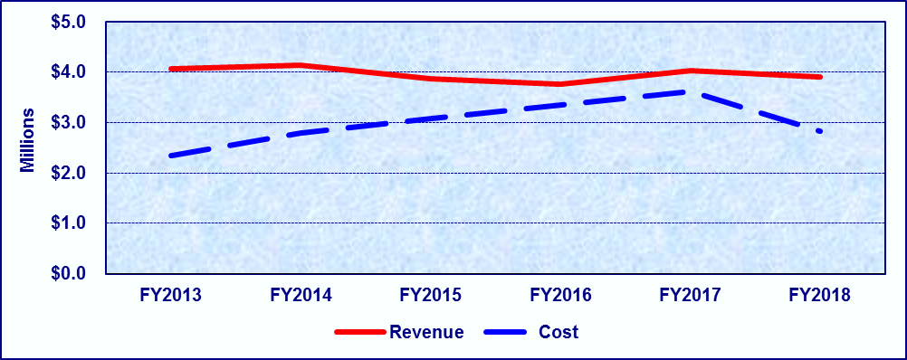
Fiscal Year | FY2013 | FY2014 | FY2015 | FY2016 | FY2017 | FY2018
Revenue | $4,078,362 | $4,134,709 | $3,865,377 | $3,771,532 | $4,034,938 | $3,907,110
Cost | $2,339,097 | $2,787,363 | $3,081,482 | $3,353,264 | $3,616,685 | $2,832,930
Percentage | 100.00% | 100.00% | 100.00% | 100.00% | 100.00% | 100.00%

Detailed Fee Schedule

Asbestos Removal Licensure
Type | Amount | Period
Notification Fee | $55 - $3,210 | Per Occurrence
Examination Fee (Unscheduled) | $50 | Per Occurrence
Examination Fee (Scheduled) | $25 | Per Occurrence
Asbestos Abatement Worker Initial and Renewal License Fee | $65 | Two Years
Asbestos Operations & Maintenance Contractor (Restricted) Initial and Renewal License Fee | $260 | Two Years
Asbestos Operations & Maintenance Supervisor (Restricted) Initial and Renewal License Fee | $225 | Two Years
Asbestos Abatement Contractor Initial and Renewal License Fee | $1,070 | Two Years
Asbestos Abatement Supervisor Initial and Renewal License Fee | $645 | Two Years
Asbestos Consultant License Initial and Renewal License Fee | $645 | Two Years
Asbestos Consultant Agency Initial and Renewal License Fee | $430 | Two Years
Asbestos Project Manager Initial and Renewal License Fee | $320 | Two Years
Asbestos Inspector Initial and Renewal License Fee | $130 | Two Years
Asbestos Management Planner Initial License Fee | $260 | Two Years
Asbestos Air Monitoring Technician Initial and Renewal License Fee | $110 | Two Years
Asbestos Management Planner Agency Initial and Renewal License Fee | $430 | Two Years
Asbestos Laboratory Initial and Renewal License Fee | $430 | Two Years
Asbestos Training Provider Initial and Renewal License Fee | $1,070 | Two Years
Asbestos Transporter Initial and Renewal License Fee | $430 | Two Years

Other Fees
Type | Amount
Late Fees All Asbestos License Renewals – Up to 90 Days | 1½ Times the Renewal Fee
Late Fees All Asbestos License Renewals – 91 Days to Less Than One Year | 2 Times the Renewal Fee
Administrative Fee for Refunds | $30
Reissue or Replacement Certificate Fee | $20

Emergency Medical Services
Date of Origin: | 1983 by S.B. 385, 68th Leg., R.S. (E.M.S.), and 1989 by H.B. 18, 71st Leg., R.S. (Trauma Facility), 2005 by S.B. 330, 79th Leg., R.S., and 2013 by H.B. 15, 83rd Leg, R.S. (Neonatal and Maternal).
Statutory Authority: | H&SC §§ 12.011, 773.050, 773.052, 773.054 - .057, 773.059, 773.071, 773.147, 773.061 (EMS); 241.83 (Neonatal and Maternal); 773.116 (Trauma); and 773.205 (Stroke)
Texas Administration Code Reference: | 25 T.A.C. §§ 157.11, 157.14, 157.32 - .34, 157.37 - .40, 157.43 - .44, 157.49 (EMS); 133.184, 133.204 (Neonatal and Maternal); 157.25 (Trauma); and 157.33 (Stroke)
Fee Set By: | Statute and Rule
Fee Capped: | Some, Varies By Fee
Description: | Fees relating to licensing of Emergency Medical Services Providers personnel, instructors, examiners, and coordinators; and trauma facilities providing emergency medical services and trauma services.
Note: | Amended by: H.B. 1407, 75th Leg., R.S., Acts 2015, 84th Leg., R.S., Ch. 1 (S.B. 219), Sec. 3.1527, eff. April 2, 2015. Acts 2015, 84th Leg., R.S., Ch. 1226 (S.B. 1899), Sec. 2, eff. June 19, 2015.
Date Due: | As determined by the Rule.
Deposit To: | General Revenue Account - Emergency Management No. 0512, Revenue Codes 3560 and 3557 (E.M.S.). Exempt from loss of dedication (S.B. 1,77th Leg. R.S.)
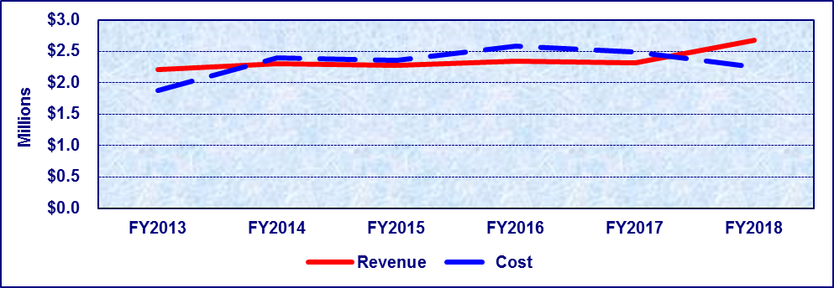
Fiscal Year | FY2013 | FY2014 | FY2015 | FY2016 | FY2017 | FY2018
Revenue | $2,202,106 | $2,306,889 | $2,278,843 | $2,341,149 | $2,314,272 | $2,673,762
Cost | $1,875,390 | $2,389,211 | $2,353,012 | $2,581,610 | $2,493,350 | $2,247,013
Percentage | 100.00% | 96.55% | 96.85% | 90.69% | 92.82% | 100.00%

Detailed Fee Schedule

Emergency Medical Services
Type | Amount | Period
Provider License Initial Application Fee | $500 | Two Years
Provider License Renewal Fee | $500 if Postmarked/Received Less Than 60 Days Before Expiration  $450 if Postmarked/Received 60 to 90 Days Before Expiration  $400 if Postmarked/Received 90 Days Before Expiration | Two Years
Provider License Vehicle Fee | $180 Per Vehicle | Two Years
Provider Add Vehicle Prorated License Fee | $90 Per Vehicle | Less Than 13 Months
Provider License Vehicle Level Change Fee | $30 | Per Occurrence
Provider License – Provisional License | $30 | Per Occurrence
Provider License Duplicate or Lost Fee | $10 | Per Occurrence
Provider Non-Compliance Re-inspection Fee | $30 | Per Occurrence
Fixed-Wing or Rotor-Wing Reciprocal Administrative Fee for Border States | $500 (in Addition to Regular Fee) | Per Occurrence
First Responder Initial Application Fee | $60 | Two Years
First Responder Renewal Application Fee | $60 | Two Years
Provisional License | $30 Plus Other License Fees | Per Occurrence
Variance Fee | $30 | Per Occurrence
ECA Course Approval Fee | $30 | Per Occurrence
EMT Course Approval Fee | $30 | Per Occurrence
EMT-I Course Approval Fee | $60 | Per Occurrence
EMT-P Course Approval Fee | $60 | Per Occurrence
EMS-I Course Approval Fee | $30 | Per Occurrence
EMS Personnel Initial and Recertification Application Fee | $60 for ECA & EMT  $90 for EMT-I & EMT-P  $120 for Licensed Paramedics | Four Years

Emergency Medical Services
Type | Amount | Period
EMT & ECA: Prorations of EMS Personnel Application Fees if Less than Four Years (Volunteer to Pay) | $15 | 1 to 12 Months Remaining
 | $30 | 13 to 24 Months Remaining
 | $45 | 25 to 36 Months Remaining
 | $60 | 37 to 48 Months Remaining
EMT-I & EMT-P: Prorations of EMS Personnel Application Fees if Less than Four Years (Volunteer to Pay) | $22.50 | 1 to 12 Months Remaining
 | $45 | 13 to 24 Months Remaining
 | $67.50 | 25 to 36 Months Remaining
 | $90 | 37 to 48 Months Remaining
Licensed Paramedic: Prorations of EMS Personnel Application Fees if Less than Four Years (Volunteer to Pay) | $30 | 1 to 12 Months Remaining
 | $60 | 13 to 24 Months Remaining
 | $90 | 25 to 36 Months Remaining
 | $120 | 37 to 48 Months Remaining
EMS Personnel Criminal Background Prescreen Fee | $50 | Per Occurrence
Inactive EMS Personnel Administrative Fee | $30 | Per Occurrence
RN Equivalency Application Fee | Same as Standard EMS Personnel Application Fees
EMS Personnel Recertification Fee | Same as Standard EMS Personnel Application Fees
EMS Personnel Returning to Active Certification Fee | Same as Standard EMS Personnel Application Fees
PA Equivalency Application Fee | Same as Standard EMS Personnel Application Fees
Application Fee for Reciprocity Certification | $120 Per Application | Per Occurrence
EMS Course Coordinator Certification Application Fee | $60 Basic  $60 Advanced | Two Years
EMS Course Coordinator Certification Prorated | $30 | One Year
Application Fee (Volunteer to Pay) | $30 | Partial Period
EMS Course Coordinator Self Study Fee | $30 Basic  $60 Advanced | Per Occurrence
EMS Course Coordinator Retest Fee | $30 | Per Occurrence
Site Visit Fees | $90 Basic  $250 Advanced | Per Occurrence
EMS Instructor Application Fee | $30 | Two Years
EMS Instructor Prorated Application Fee (Volunteer to Pay) | $30  $15 | One Year Partial Period
Emergency Medical Information Operator Instructor Fee | $60 | Two Years
Emergency Medical Information Operator Instructor Course Approval Fee | $60 | Per Occurrence
Emergency Medical Information Operator Instructor Course Fee | $60 | Per Occurrence
Emergency Medical Information Operator Instructor Retest Fee | $30 | Per Occurrence
CE Program Fee | $60 | Per Occurrence

Other Fees
Type | Amount
EMS Personnel Late Recertification Fee – Up to 90 Days | 1½ Times the Recertification Fee
EMS Personnel Late Recertification Fee – 91 Days to Less Than One Year | 2 Times the Recertification Fee
EMS Course Coordinator Recertification Late Fee – Up to 90 Days | 1½ Times the Recertification Fee
EMS Course Coordinator Recertification Late Fee – 91 Days to Less Than One Year | 2 Times the Recertification Fee
EMS Instructor Recertification Late Fee – Up to 90 Days | 1½ Times the Recertification Fee
EMS Instructor Recertification Late Fee – 91 Days to Less Than One Year | 2 Times the Recertification Fee
EMS Personnel Duplicate Certificate Fee | $10

Emergency Stroke Services
Type | Amount | Period
Application Fee | $100 | Two Years

Hospital Level of Care Designations for Neonatal and Maternal Care
Type | Amount | Period
Application Fee | Level I neonatal facility applicants,  $ <=100 licensed beds, the fee is $250.00; or  $ >100 licensed beds, the fee is $750.00.  Level II neonatal facility applicants, the fee is $1,500.00.  Level III neonatal facility applicants, the fee is $2,000.00.  Level IV neonatal facility applicants, the fee is $2,500.00. | Three Years

Trauma Designation
Type | Amount | Period
Application Fee | Level I and Level II trauma facility applicants, the fee will be no more than $10 per licensed bed with an upper limit of $5,000 and a lower limit of $4,000;  Level III trauma facility applicants, the fee will be no more than $10 per licensed bed with an upper limit of $2,500 and a lower limit of $1,500; and  Level IV trauma facility applicants, the fee will be no more than $10 per licensed bed with an upper limit of $1000 and a lower limit of $500. | Three Years

Food and Drug Wholesale Distribution/Manufacturing
Date of Origin: | 1911 by the 32nd Leg. (Food), 1963 by the 58th Leg. (Drug), and 1989 by H.B. 2505, 71st Leg., R.S. (Certificate of Free Sale).
Statutory Authority: | H&SC §§ 431.222 and 431.224 (Food Manufacturers and Food Wholesalers), 431.204 (Wholesale Distributors of Nonprescription Drugs), 431.409 (Wholesale Distributors of Prescription Drugs), 431.241 (g) (Certificate of Free Sale), 12.0111 (Licensing Fee)
Texas Administration Code Reference: | 25 T.A.C. §§ 229.182 (Food Manufacturers and Food Wholesalers), 229.249 (Wholesale Distributors of Nonprescription Drugs), 229.427 (Wholesale Distributors of Prescription Drugs), 229.306 (Certificates of Free Sale)
Fee Set By: | Rule
Fee Capped: | No
Description: | A license for each place of business is required for a person to engage in the wholesale distribution, which is the selling of large quantities of Food or Drugs (non-prescription or prescription) that will be sold by retailers.
Note: | Amended by S.B. 873, 72nd, Leg., R.S. (Drug)  Amended by Acts 1993, 73rd Leg., ch 713, § 1 (Food)  Amended by Acts 1993, 73rd Leg., ch 675, § 7 (Certificate of Free Sale) Added by Acts 2005, ch 282, § 3(g), 79th Leg.  Amended by: Acts 2015, 84th Leg., R.S., Ch. 1 (S.B. 219), Sec. 3.1000, eff. April 2, 2015.
Date Due: | At time of application, renewal or issuance of a certificate of free sale.
Deposited To: | General Revenue Account – Food and Drug Registration No. 5024, Revenue Codes 355403, 355407, and 355413. Exempt from loss of dedication (S.B. 1,77th Leg. R.S.)
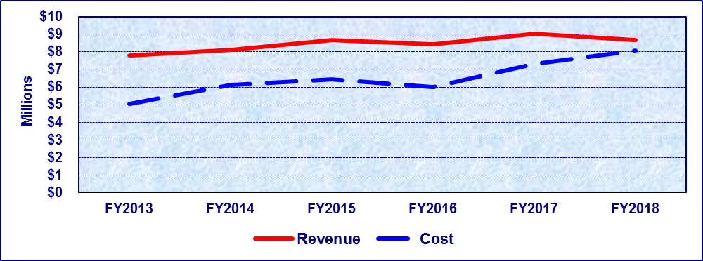
Fiscal Year | FY2013 | FY2014 | FY2015 | FY2016 | FY2017 | FY2018
Revenue | $7,786,373 | $8,094,395 | $8,680,993 | $8,413,631 | $9,048,233 | $8,661,758
Cost | $5,052,220 | $6,137,131 | $6,441,229 | $5,983,658 | $7,278,909 | $8,084,771
Percentage | 100.00% | 100.00% | 100.00% | 100.00% | 100.00% | 100.00%
*Cost for FY2017 reflects corrected amount that differs from the cost in the FY2017 Fee Resource Manual.

Detailed Fee Schedule

Food & Drug Wholesale Distribution/Manufacturing

Food Manufacturers, Private Labelers, Re-packers
Type | Amount | Period
Gross Annual Sales: $0 – $9,999.99 | $100 | Two Years
License Amendment Fee: $0 – $9,999.99 | $50 | Per Occurrence
Gross Annual Sales: $10,000 – $24,999.99 | $150 | Two Years
License Amendment Fee: $10,000 – $24,999.99 | $75 | Per Occurrence
Gross Annual Sales: $25,000 – $99,999.99 | $250 | Two Years
License Amendment Fee: $25,000 – $99,999.99 | $125 | Per Occurrence
Gross Annual Sales: $100,000 – $199,999.99 | $560 | Two Years
License Amendment Fee: $100,000 – $199,999.99 | $280 | Per Occurrence
Gross Annual Sales: $200,000 – $999,999.99 | $900 | Two Years
License Amendment Fee: $200,000 – $999,999.99 | $450 | Per Occurrence
Gross Annual Sales: $1,000,000 – $9,999,999.99 | $1,120 | Two Years
License Amendment Fee: $1,000,000 – $9,999,999.99 | $560 | Per Occurrence
Gross Annual Sales: $10,000,000 or More | $1,680 | Two Years
License Amendment Fee: $10,000,000 or More | $840 | Per Occurrence

Food Wholesaler
Type | Amount | Period
Gross Annual Sales: $0 – $199,999.99 | $250 | Two Years
License Amendment Fee: $0 – $199,999.99 | $125 | Per Occurrence
Gross Annual Sales: $200,000 – $499,999.99 | $450 | Two Years
License Amendment Fee: $200,000 – $499,999.99 | $225 | Per Occurrence
Gross Annual Sales: $500,000 – $999,999.99 | $680 | Two Years
License Amendment Fee: $500,000 – $999,999.99 | $340 | Per Occurrence
Gross Annual Sales: $1,000,000 – $9,999,999.99 | $900 | Two Years
License Amendment Fee: $1,000,000 – $9,999,999.99 | $450 | Per Occurrence
Gross Annual Sales: $10,000,000 or More | $1,350 | Two Years
License Amendment Fee: $10,000,000 or More | $675 | Per Occurrence
Food Wholesaler Registration | $100 | Two Years
Food Wholesaler Registration License Amendment Fee | $50 | Per Occurrence

Food Warehouse Operator
Type | Amount | Period
Food Storage: 0 – 6,000 sq ft | $350 | Two Years
License Amendment Fee: 0 – 6,000 sq ft | $175 | Per Occurrence
Food Storage: 6,001– 24,000 sq ft | $700 | Two Years
License Amendment Fee: 6,001– 24,000 sq ft | $350 | Per Occurrence
Food Storage: 24,001 – 75,000 sq ft | $1,050 | Two Years
License Amendment Fee: 24,001 – 75,000 sq ft | $525 | Per Occurrence
Food Storage: 75,001 – 250,000 sq ft | $1,400 | Two Years
License Amendment Fee: 75,001 – 250,000 sq ft | $700 | Per Occurrence
Food Storage: 250,001 or More sq ft | $2,000 | Two Years
License Amendment Fee: 250,001 or More sq ft | $1,000 | Per Occurrence

In-State Wholesale Distributors or Manufacturers of Non-Prescription Drugs
Type | Amount | Notes | Period
Gross Annual Sales: $0 – $199,999.99 | $1,040 | Effective 05/01/07 | Two Years
License Amendment Fee: $0 – $199,999.99 | $520 | Effective 05/01/07 | Per Occurrence
Gross Annual Sales: $200,000 – $19,999,999.99 | $1,690 | Effective 05/01/07 | Two Years
License Amendment Fee: $200,000 – $19,999,999.99 | $845 | Effective 05/01/07 | Per Occurrence
Gross Annual Sales: $20,000,000 or More | $2,210 | Effective 05/01/07 | Two Years
License Amendment Fee: $20,000,000 or More | $1,105 | Effective 05/01/07 | Per Occurrence

Out of State Drug Firms
Type | Amount | Notes | Period
Gross Annual Sales: $0 - $19,999,999 | $1,300 | Effective 05/01/07 | Two Years
Gross Annual Sales: $20,000,000 or More | $1,950 | Effective 05/01/07 | Two Years

License Amendment Fee Out of State Firms
Type | Amount | Notes | Period
Gross Annual Sales: $0 - $19,999,999 | $650 | Effective 05/01/07 | Per Occurrence
Gross Annual Sales: $20,000,000 or More | $975 | Effective 05/01/07 | Per Occurrence

In-State and Out-of-State Wholesale Distributors or Manufacturers of Prescription Drugs
Type | Amount | Notes | Period
License Amendment Fee: $20,000,000 or More | $1,147 | Effective 05/01/07 | Per Occurrence
License Replacement Fee (Prescription Drugs only) | $100 | Effective 12/09/10 | Per Occurrence

Combined Multiple Product Distributors – Wholesale Food, Non Prescription Drug and/or Device
Type | Amount | Notes | Period
Gross Annual Sales: $0 – $199,999.99 | $520 | Effective 05/01/07 | Two Years
License Amendment Fee: $0 – $199,999.99 | $260 | Effective 05/01/07 | Per Occurrence
Gross Annual Sales: $200,000 – $499,999.99 | $780 | Effective 05/01/07 | Two Years
License Amendment Fee: $200,000 – $499,999.99 | $390 | Effective 05/01/07 | Per Occurrence
Gross Annual Sales: $500,000 – $999,999.99 | $1,040 | Effective 05/01/07 | Two Years
License Amendment Fee: $500,000 - $999,999.99 | $520 | Effective 05/01/07 | Per Occurrence
Gross Annual Sales: $1,000,000 – $9,999,999.99 | $1,300 | Effective 05/01/07 | Two Years
License Amendment Fee: $1,000,000 – $9,999,999.99 | $650 | Effective 05/01/07 | Per Occurrence
Gross Annual Sales: $10,000,000.00 or More | $1,950 | Effective 05/01/07 | Two Years
License Amendment Fee: $10,000,000.00 or More | $975 | Effective 05/01/07 | Per Occurrence

Combined Multiple Product Distributors – Wholesale Food, Including Medical Gases and/or Device
Type | Amount | Notes | Period
Gross Annual Sales: $0 – $199,999.99 | $540 | Effective 05/01/07 | Two Years
License Amendment Fee: $0 – $199,999.99 | $270 | Effective 05/01/07 | Per Occurrence
Gross Annual Sales: $200,000 – $499,999.99 | $810 | Effective 05/01/07 | Two Years
License Amendment Fee: $200,000 – $499,999.99 | $405 | Effective 05/01/07 | Per Occurrence
Gross Annual Sales: $500,000 – $999,999.99 | $1,080 | Effective 05/01/07 | Two Years
License Amendment Fee: $500,000 - $999,999.99 | $540 | Effective 05/01/07 | Per Occurrence
Gross Annual Sales: $1,000,000 – $9,999,999.99 | $1,350 | Effective 05/01/07 | Two Years
License Amendment Fee: $1,000,000 – $9,999,999.99 | $675 | Effective 05/01/07 | Per Occurrence
Gross Annual Sales: $10,000,000.00 or More | $2,025 | Effective 05/01/07 | Two Years
License Amendment Fee: $10,000,000.00 or More | $1,012 | Effective 05/01/07 | Per Occurrence
Inspection of Cosmetic Distributors/Manufacturers | $400 |  | Two Years

Other Fees
Type | Amount
Food and Drug Late Fee | $100
Original Certificate of Free Sale and/or Certificate of Origin 1 to 50 Products | $50
Additional Identical Certificate of Free Sale and/or Certificate of Origin 1 to 50 Products | $5
Original Certificate of Free Sale and/or Certificate of Origin 51 to 200 Products | $60
Additional Identical Certificate of Free Sale and/or Certificate of Origin 1 to 50 products | $6
Original Certificate of Free Sale and/or Certificate of Origin 201 to 500 Products | $75
Each Additional Identical Certificate of Free Sale and/or Certificate of Origin 201 to 500 Products | $8
Original Certificate of Free Sale and/or Certificate of Origin 501 to 1000 Products | $100
Each Additional Identical Certificate of Free Sale and/or Certificate of Origin 501 to 1000 Products | $10
Original Certificate of Free Sale and/or Certificate of Origin 1001 Products and Over | $150
Each Additional Identical Certificate of Free Sale and/or Certificate of Origin 1001 Products and Over | $15
Non-license Inspection Fee (Cosmetics and Single Service Container) | $400
Supplemental Review Fee | $72/hour
Custom Certificate Fee | $72/hour

Food Service Establishments
Date of Origin: | 1993 by S.B. 1421, 73rd Leg., R.S.
Statutory Authority: | H&SC §§ 12.0111, 437.0125 (Fees)
Texas Administration Code Reference: | 25 T.A.C. §§ 229.372
Fee Set By: | Rule
Fee Capped: | No
Description: | Fees relating to permitting and inspection of food service establishments, retail food stores, mobile food units or temporary food services establishments.
Note: | Amended by: Acts 2015, 84th Leg., R.S., Ch. 1 (S.B. 219), Sec. 5.102, eff. April 2, 2015.
Date Due: | At time of application or biennial renewal.
Deposited To: | General Revenue Account - Food and Drug Retail Fee No. 0341, Revenue Code 3554. Exempt from loss of dedication (S.B. 1,77th Leg. R.S.)
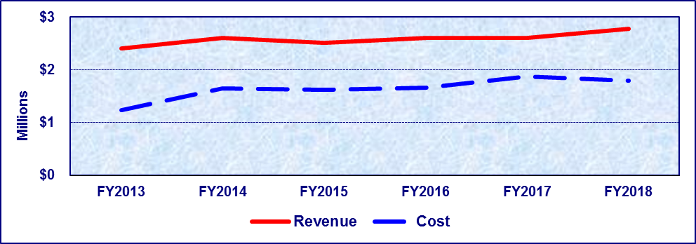
Fiscal Year | FY2013 | FY2014 | FY2015 | FY2016 | FY2017 | FY2018
Revenue | $2,404,853 | $2,607,585 | $2,508,229 | $2,606,282 | $2,600,275 | $2,776,912
Cost | $1,240,437 | $1,647,197 | $1,615,822 | $1,654,663 | $1,867,095 | $1,787,470
Percentage | 100.00% | 100.00% | 100.00% | 100.00% | 100.00% | 100.00%

Detailed Fee Schedule

Food Service Establishments
Type | Amount | Period
Gross Annual Sales: $0 – $49,999.99 | $250 | Two Years
License Amendment Fee: $0 – $49,999.99 | $125 | Per Occurrence
Gross Annual Sales: $50,000 – $149,999.99 | $500 | Two Years
License Amendment Fee: $50,000 – $149,999.99 | $250 | Per Occurrence
Gross Annual Sales: $150,000 or More | $750 | Two Years
License Amendment Fee: $150,000.00 or More | $375 | Per Occurrence
Gross Annual Volume Retail Food Store | Same as Above | Same as Above
Institutional Food Service License | $250 | Two Years
Institutional Food Service License Amendment Fee | $125 | Per Occurrence
Roadside Food Vendor License | $250 | Two Years
Roadside Food Vendor License Amendment Fee | $125 | Per Occurrence
Mobile Food Unit Fee License | $250 | Two Years
Mobile Food Unit License Amendment Fee | $125 | Per Occurrence
Single Event Temporary Food Service Permit | $50 | Not to Exceed 14 Consecutive Days
Multiple Event Temporary Food Service Permit | $200 | Two Years
Non-Permitted Food Establishments | $150 Per Inspection | Per Occurrence
Late Fee | $100

Low Level Radioactive Waste
Date of Origin: | Acts 1989, 71st Leg., ch. 678, Sec. 1, eff. Sept. 1, 1989.
Statutory Authority: | H&SC §§ 401.301(d) (5% surcharge), 401.052(d) (Out of Compact Waste Shippers Fee), 401.307 (RPCA Caps)
Texas Administrative Code Reference: | 25 T.A.C § 289.257(dd) (Fees), 25 T.A.C. § 289.204(d)(5) (5% surcharge)
Fee Set By: | Rule
Fee Capped: | Yes, H&SC § 401.307 and 25 T.A.C. § 289.257(dd)(2) {note fee cap for “party state” waste generators}
Description: | Fees are assessed on shippers of low level radioactive waste to be disposed at a designated disposal site in Texas. These bills are generated from complete shipment manifests provided to the department by the disposal site.
Note: | Amended by: Leg. Session 83(R) SB 347 effective 09/01/2013
Due Date: | Low Level Waste- By occurrence; 5% RPCA- Radiation Program makes quarterly transfers
Deposit To: | General Revenue Account – Perpetual Care Account No. 5096, Revenue Code 3589.
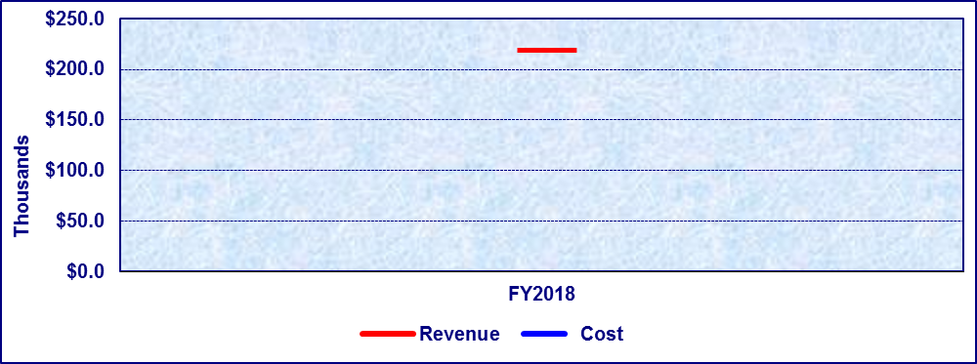
Fiscal Year | FY2018
Revenue | $215,916
Cost | $0
Percentage | 100.00%
*Costs occur only if remediation is conducted.

Detailed Fee Schedule

Low Level Radioactive Waste
Type | Amount | Period
5% license surcharge | 5% of license fee | Two Years
Waste Fee | $10/cubic foot | Per waste shipment occurrence

Mammography Systems Certification and Accreditation
Date of Origin: | 1993 by H.B. 63, 73rd Leg., R.S.
Statutory Authority: | H&SC §§ 401.427 (Fees)
Texas Administrative Code Reference: | 25 T.A.C. §§ 289.230 (Fees)
Fee Set By: | Rule
Fee Capped: | No
Description: | Fees related to the certification of mammography systems. A person may not perform mammography unless the mammography system used has been certified. Fees related to the accreditation of mammography facilities.
Note: | Amended by: 2001 by H.B. 1099, 77th Leg. R.S.; 2007 by H.B. 2285 and S.B. 1604, 80th Leg., R.S.; 2013 by S.B. 347, 83rd Leg., R.S.; Acts 2015, 84th Leg., R.S., Ch. 1 (S.B. 219), Sec. 5.102, eff. April 2, 2015.
Due Date: | Initial and renewal licensure fee – upon application/renewal.
Deposit To: | General Revenue Account – Certification of Mammography Systems No. 5021, Revenue Code 3557. Exempt from loss of dedication (S.B. 1,77th Leg. R.S.)
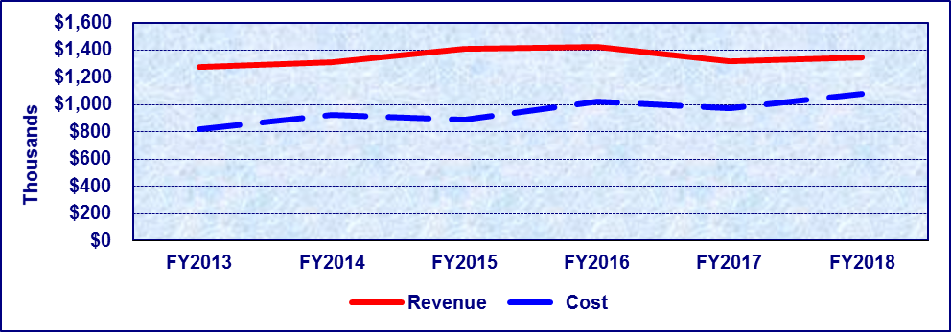
Fiscal Year | FY2013 | FY2014 | FY2015 | FY2016 | FY2017 | FY2018
Revenue | $1,275,492 | $1,306,294 | $1,408,985 | $1,419,839 | $1,314,452 | $1,345,069
Cost | $814,582 | $924,288 | $889,665 | $1,021,824 | $970,743 | $1,076,774
Percentage | 100.00% | 100.00% | 100.00% | 100.00% | 100.00% | 100.00%

Detailed Fee Schedule

Mammography Systems Certification and Accreditation
Type | Amount | Period
Initial Certification Mammography Systems | $2,010 Per Machine | One Year
Initial Certification for Additional Mammography Systems That Have Not Been Assigned a Separate United States FDA Administration Identification Number Shall be Authorized on the Same Certification | $240 Per Machine | One Year
Annual Fee (After Initial Certification) Mammography Systems | $2,010 Per Machine | One Year
Annual Fee (After Initial Certification) for Additional Mammography Systems (On the Same Certification) | $240 Per Machine | One Year
Initial Certification for Machines Used for Interventional Breast Radiography | $490 Per Machine | One Year
Initial Certification for Additional Machines Used for Interventional Breast Radiography (On the Same Certification) | $240 Per Machine | One Year
Annual Fee (After Initial Certification) for Machines Used for Interventional Breast Radiography | $490 Per Machine | One Year
Annual Fee (After Initial Certification) for Additional Machines Used for Interventional Breast Radiography (On the Same Certification) | $240 Per Machine | One Year
Accreditation Fee for First Mammography Machine | $1,025 Per Machine | Three Years
Accreditation Fee for Each Additional Mammography Machine | $610 Per Machine | Three Years
Fee for Re-evaluation of Clinical Images | $330 Per Unit | Per Occurrence
Fee for Re-evaluation of Phantom Images | $300 Per Unit | Per Occurrence
Fee for Additional Required Mammography Review | Based on Number of Clinical Images Reviewed and the Type of Review | Per Occurrence
Fee for Reinstatement of Mammography Machine | $610 | Per Occurrence
Required Targeted Clinical Imaging Review Fee | Actual Expenses | Per Occurrence
Fee for the Review of Clinical Images for Dual Modality Mammography Machines | $330 | Per Occurrence
On-site Visit For Three Denials of Accreditation | Actual Expenses | Per Occurrence

Medical Device Distributor and Manufacturer
Date of Origin: | 1993 by S.B. 564, 73rd Leg., R.S.
Statutory Authority: | H&SC §§ 12.0111, 431.276 (Fees)
Texas Administrative Code Reference: | 25 T.A.C. §§ 229.439 (Fees)
Fee Set By: | Rule
Fee Capped: | No
Description: | A license for each place of business is required in order for a person to engage in the manufacture and the wholesale distribution and manufacturing of medical devices such as pacemakers, powered wheelchairs, or breast implants.
Note: | Amended by: Acts 2015, 84th Leg., R.S., Ch. 1 (S.B. 219), Sec. 3.1000, eff. April 2, 2015.
Date Due: | At time of application or biennial renewal.
Deposited To: | General Revenue Account – Medical Device Distributor and Manufacturer No. 5024, Revenue Code 355405. Exempt from loss of dedication (S.B. 1, 77th Leg. R.S.)
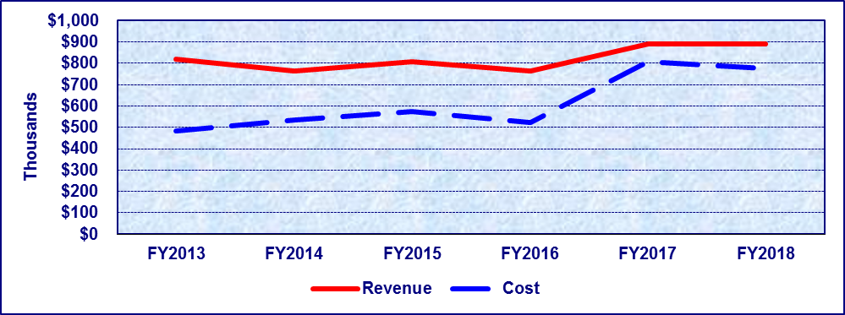
Fiscal Year | FY2013 | FY2014 | FY2015 | FY2016 | FY2017 | FY2018
Revenue | $818,873 | $764,307 | $809,116 | $764,694 | $891,421 | $888,560
Cost | $481,928 | $533,852 | $572,744 | $522,784 | $803,291 | $775,518
Percentage | 100.00% | 100.00% | 100.00% | 100.00% | 100.00% | 100.00%
*Revenue from FY2013-FY2015 for Medical Device Distributor and Manufacturer was classified as General Revenue until FY2016 when revenue was collected under Fund 5024 and reclassified as Dedicated General Revenue.
**Cost for FY2017 reflects corrected amount that differs from the cost in the FY2017 Fee Resource Manual.

Detailed Fee Schedule

Medical Device Distributor and Manufacturer

Device Distributors
Type | Amount | Period
Gross Annual Sales: $0 – $499,999.99 | $480 | Two Years
License Amendment Fee: $0 – $49,999.99 | $240 | Per Occurrence
Gross Annual Sales: $500,000 – $9,999,999.99 | $1,080 | Two Years
License Amendment Fee: $500,000 –$9,999,999.99 | $540 | Per Occurrence
Gross Annual Sales: $10,000,000 or More | $1,680 | Two Years
License Amendment Fee: $10,000,000 or More | $840 | Per Occurrence

Device Manufacturers
Type | Amount | Period
Gross Annual Sales: $0 – $499,999.99 | $480 | Two Years
License Amendment Fee: $0 – $499,999.99 | $240 | Per Occurrence
Gross Annual Sales: $500,000 – $9,999,999.99 | $2,160 | Two Years
License Amendment Fee: $500,000 –$9,999,999.99 | $1,080 | Per Occurrence
Gross Annual Sales: $10,000,000 or More | $3,600 | Two Years
License Amendment Fee: $10,000,000 or More | $1,800 | Per Occurrence

Combined Multiple Product Distributors – Food, Non-Prescription Drug and/or Devices
Type | Amount | Period
Gross Annual Sales: $0 – $199,999.99 | $520 | Two Years
License Amendment Fee: $0 – $199,999.99 | $260 | Per Occurrence
Gross Annual Sales: $200,000 – $499,999.99 | $780 | Two Years
License Amendment Fee: $200,000 – $499,999.99 | $390 | Per Occurrence
Gross Annual Sales: $500,000 – $999,999.99 | $1,040 | Two Years
License Amendment Fee: $500,000 – $999,999.99 | $520 | Per Occurrence
Gross Annual Sales: $1,000,000 – $9,999,999.99 | $1,300 | Two Years
License Amendment Fee: $1,000,000 –$9,999,999.99 | $650 | Per Occurrence
Gross Annual Sales: $10,000,000 or More | $1,950 | Two Years
License Amendment Fee: $10,000,000 or More | $975 | Per Occurrence

Other Costs
Type | Amount
Device Late Fee | $100

Oyster Sales
Date of Origin: | 1989 by H.B. 1821, 71st Leg., R.S. (Parks and Wildlife Code ch. 76). 1993 by SB 556, 73rd Leg., R.S. (Health and Safety Code ch. 436).
Statutory Authority: | H&SC §§ 436.103 (Fees), 12.0111 (Licensing Fee)
Texas Administration Code Reference: | 31 T.A.C. § 58.24
Fee Set By: | Statute
Fee Capped: | Yes
Description: | Fees collected for each barrel of oysters harvested, purchased, handled, or processed by a certified shellfish dealer.
Note: | Amended by Acts 1999, 76th Leg. Ch. 1298, § 2.  Amended by Acts 2013, 83rd Leg., R.S., Ch. 965 (H.B. 1903), Sec. 1.  Amended by Acts 2015, 84th Leg., R.S., Ch. 1 (S.B. 219), Sec. 5.102, eff. April 2, 2015.
Date Due: | To Office of the Comptroller not later than the 20th day of the month following the month in which the barrel of oysters was handled.
Deposited To: | General Revenue Account – Oyster Sales No. 5022, Revenue Code 3436. Exempt from loss of dedication (S.B. 1,77th Leg. R.S.)
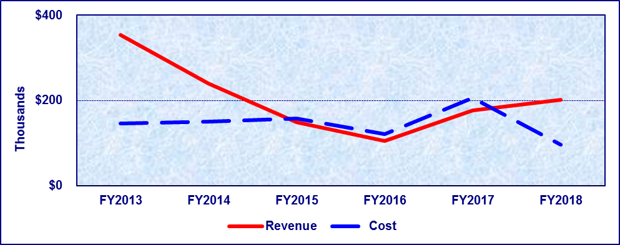
Fiscal Year | FY2013 | FY2014 | FY2015 | FY2016 | FY2017 | FY2018
Revenue | $353,745 | $239,266 | $149,336 | $105,216 | $177,272 | $200,765
Cost | $146,035 | $150,674 | $158,096 | $120,296 | $206,312 | $95,922
Percentage | 100.00% | 100.00% | 94.46% | 87.46% | 85.92% | 100.00%

Detailed Fee Schedule

Oyster Sales
Type | Amount
Per Barrel of Oysters Harvested, Purchased, Handled, or Processed | $1
Weight Penalty Fee Per Container Exceeding 110 lbs | $5 Per Container
Late Payment Penalty | 10% of Original Fee

Public Health Services
Date of Origin: | 1983 by S.B. 1047, 68th Leg., R.S.
Statutory Authority: | H&SC §§ 12.0122, 12.031 – 12.039, 12.0127 (Fees).
Texas Administration Code Reference: | 25 T.A.C. §§ 13.2, 73.31, 73.41, 73.51, 73.54, 73.55 and 97.124.
Fee Set By: | Rule
Fee Capped: | No
Description: | Fees charged to persons who receive public health services from the Department including, but not limited to, distribution and administration of vaccines and serums, the Rabies Control Act, and the Communicable Disease Prevention and Control Act
Note: | Amended by: Acts 2015, 84th Leg., R.S., Ch. 1 (S.B. 219), Sec. 3.0014, eff. April 2, 2015.
Date Due: | As determined by the rule.
Deposited To: | General Revenue Account – Public Health Service Fee No. 0524, Revenue Codes: 3595, 3561, and 3727. Exempt from loss of dedication (§ 403.095 Government Code)
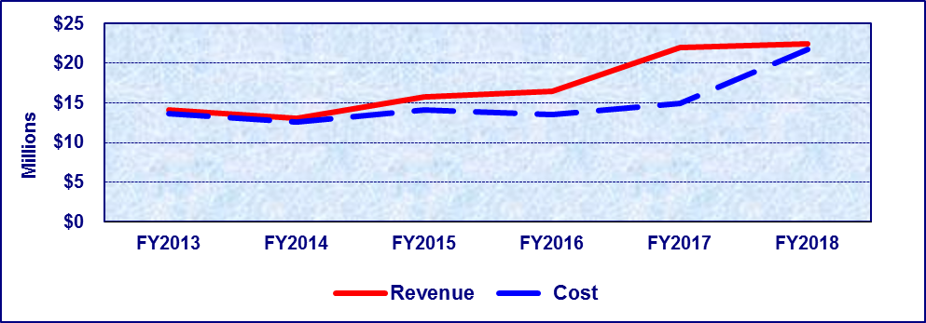
Fiscal Year | FY2013 | FY2014 | FY2015 | FY2016 | FY2017 | FY2018
Revenue | $14,119,156 | $13,108,569 | $15,718,864 | $16,478,714 | $21,915,194 | $22,419,216
Cost | $13,619,279 | $12,635,722 | $14,081,656 | $13,534,134 | $14,905,520 | $21,731,403
Percentage | 100.00% | 100.00% | 100.00% | 100.00% | 100.00% | 100.00%
*Appropriations from General Revenue Dedicated Account – Public Health Service Fee No. 0524 increased in FY2018.

Detailed Fee Schedule

Public Health Services (All Fees Not to Exceed)

Human Testing

Biochemistry and Genetics / Newborn Screening:
Procedure Name | Procedure No. | CPT | Cost
Hemoglobin Electrophoresis | BZZ0008A | 83020 / 83021 | $3.98
Newborn Screening Panel Test Kit (Private Pay) Fee | N/A | N/A | $55.24
Phenylalanine/Tyrosine | BZZ0003A | 83789 | $16.61

Biochemistry and Genetics / Newborn DNA Analysis:
Procedure Name | Procedure No. | CPT | Cost
Cystic Fibrosis: Common Mutation Panel | BAR0125Z | 81220 | $175.19
Galactosemia: Common Mutation Panel | BAE0056Z | 81401 | $529.03
Hemoglobin DNA Test: Beta-Globin Gene Sequencing | BAN0114Z | 81401 | $1,054.24
Hemoglobin DNA Test: Common Beta - Thalassemia Mutation | BAM0108Z | 81401 | $287.66
Hemoglobin DNA Test: Hb, S, C, E, D or O - Arab | BAH0080Z | 81401 | $255.72
Medium Chain Acyl-CoA Dehydrogenase Deficiency (MCAD) Mutation Panel | BAT0139Z | 81401 | $374.95
VLCAD – Full Gene Sequencing | BAU0145Z | 81406 | $1,596.93

Biochemistry and Genetics / Clinical Chemistry:
Procedure Name | Procedure No. | CPT | Cost
Cholesterol | BZZ0015A | 82465 | $5.18
Glucose Fasting | BZZ0106A | 82947 | $4.30
Glucose Random | BZZ0107A | 82947 | $4.30
Hemoglobin | BZZ0024A | 85018 | $1.53
High Density Lipoprotein (HDL) | BZZ0026A | 83718 | $6.02
Lead | BZZ0023A | 83655 | $3.47
Lipid Panel (Includes Cholesterol, Triglycerides, High Density Lipoprotein (HDL), and Low-Density Lipoprotein (LDL) | BZZ0022A | 80061 | $15.04
Creatinine | BZZ0033A | 82565 | $1.30

Microbiology Human and Non-Human Testing

Microbiological Sciences / Serological Analysis:
NOTE: Charges for Microbiological Sciences testing will be based upon the actual testing performed as determined by suspect organisms, specimen type, and clinical history provided.
Procedure Name | Procedure No. | CPT | Cost
Brucella IgG | MZZ0135A | 86622 | $44.10
Chagas, IgG | MPS0010A | 86753 | $27.68
Chikungunya, IgM | MAM0087A | 86790 | $74.72
Dengue, IgM EIA | MAM0086A | 86790 | $58.11
Emerging Disease, IgM | MAM0088A | 86790 | $74.72
Zika Virus IgM | MAM0089A | 86790 | $74.72
Francisella, IgG | MZZ0336A | 86668 | $61.15
Gonorrhea/Chlamydia (GC/CT), Amplified RNA probe | MBB0191A | 87491, 87591 | $20.28
Hantavirus IgG/IgM | MBC0198A | 86790 | $362.05
Hepatitis A, IgM | MBD0201A | 86709 | $44.04
Hepatitis A, Total | MBE0203A | 86708 | $34.45
Hepatitis B Core Antibody | MBF0205A | 86704 | $36.06
Hepatitis B Core IgM Antibody | MZZ0214A | 86705 | $44.75
Hepatitis B Surface Antibody (Ab) | MBJ0211A | 86706 | $28.34
Hepatitis B Surface Antigen (Ag) | MBK0213A | 87340 | $18.47
Hepatitis C (HCV) | MBL0217A | 86803 | $25.68
HIV Combo Ag/Ab | MBP0229A | 87389 | $7.90
HIV Serum Confirmation Test | MBP0231A | 86701, 86702 | $83.74
Measles, IgG | MCW0330A | 86765 | $21.35
Measles, IgM | MCW0328A | 86765 | $85.60
Mumps, IgG | MCC0276A | 86735 | $22.62
Q-Fever, IgG | MCL0292A | 86638 | $85.61
QuantiFERON -TB Serology | MZZ0468A | 86480 | $53.66
Rocky Mountain Spotted Fever, IgG | MCR0317A | 86757 | $42.93
Rubella IgM (German Measles) | MCT0320A | 86762 | $24.77
Rubella Screen IgG (German Measles) | MCU0322A | 86762 | $22.33
Schistosoma (EIA) | MPS0010A | 86682 | $10.30
St. Louis Encephalitis (SLE), IgM EIA | MAM0460A | 86653 | $107.84
Strongyloides (EIA) | MPS0002A | 86682 | $16.89
Syphilis Confirmation Particle Agglutination (TP-PA) | MCS0318A | 86780 | $27.02
Syphilis Rapid Plasma Regain (RPR) – Qualitative | MBY0264A | 86592 | $2.89
Syphilis Rapid Plasma Regain (RPR) – Quantitative | MBN0224A | 86593 | $12.88
Syphilis Screen, IgG | MBN0222A | 86780 | $7.57
Typhus Fever, IgG | MCR0318A | 86757 | $42.93
West Nile Virus (WN), IgG EIA | MZZ0082A | 86788 | $107.84
Yersinia Pestis (Plague) Serum | MCG0282A | 86793 | $237.18

Microbiological Sciences / Molecular Biology:
NOTE: Charges for Microbiological Sciences testing will be based upon the actual testing performed as determined by suspect organisms, specimen type, and clinical history provided.
Procedure Name | Procedure No. | CPT | Cost
Arbovirus Polymerase Chain Reaction (PCR) Eastern Equine Encephalitis (EEE) Mosquitoes | MMB1026A | N/A | $60.39
Arbovirus Polymerase Chain Reaction (PCR) St. Louis Encephalitis (SLE) Mosquitoes | MMB1022A | N/A | $60.18
Arbovirus Polymerase Chain Reaction (PCR) Western Equine Encephalitis (WEE) Mosquitoes | MMB1020A | N/A | $60.41
Arbovirus Polymerase Chain Reaction (PCR) West Nile Virus (WNV) Mosquitoes | MMB1040A | N/A | $57.87
Arbovirus Polymerase Chain Reaction (PCR) Eastern Equine Encephalitis (EEE) | MMB0026A | N/A | $60.39
Arbovirus Polymerase Chain Reaction (PCR) St. Louis Encephalitis (SLE) | MMB0022A | N/A | $60.18
Arbovirus Polymerase Chain Reaction (PCR) Western Equine Encephalitis (WEE) | MMB0020A | N/A | $60.41
Polymerase Chain Reaction (PCR) West Nile Virus | MMB0040A | N/A | $57.87
Bordetella Pertussis, Parapertussis, and Bordetella Holmesii Polymerase Chain Reaction (PCR) | MZZ0377A | 87798 | $213.79
Bacteriology Pulsed Field Gel Electrophoresis (PFGE) | MCA0266A | 87152 | $112.67
Malaria Polymerase Chain Reaction (PCR) | MMB0030A | 87798 | $141.79
Norovirus (Norwalk-Like Virus) Polymerase Chain Reaction (PCR) | MZZ0450A | 87798 | $162.96
Salmonella Serotyping | MAA0005A | 87077 | $86.63
Shiga Toxin Producing E. Coli Polymerase Chain Reaction (PCR) | MMB0004A | 87150 | $117.90
Shigella Serotyping | MAA0004A | 87077 | $120.38
Rotovirus Polymerase Chain Reaction (PCR) | MMB0002A | 87798 | $55.75

Microbiological Sciences / Mycobacteriology/ Mycology:
NOTE: Charges for Microbiological Sciences testing will be based upon the actual testing performed as determined by suspect organisms, specimen type, and clinical history provided.
Procedure Name | Procedure No. | CPT | Cost
Acid Fast Bacilli (AFB) Culture | MZZ0062A | 87116 | $32.04
Acid Fast Bacilli (AFB) Direct Detection by High-Performance Liquid Chromatography (HPLC) | MAF0064A | 87143 | $66.26
Acid Fast Bacilli (AFB) Isolate Identification; High- Performance Liquid Chromatography (HPLC) | MAC0052A | 87143 | $124.90
Acid Fast Bacilli (AFB) Isolate Identification; Probe | MAC0053A | 87149 | $81.40
Acid Fast Bacilli (AFB) Biochemicals; Basic | MZZ0451A | 87118 | $132.35
Acid Fast Bacilli (AFB) Biochemicals; Complex | MZZ0455A | 87118 | $472.84
Nucleic Acid Amplification for Mycobacterium Tuberculosis Complex | MAB0050A | 87556 | $166.70
Acid Fast Bacilli (AFB) Specimen Concentration | MAG0066A | 87015 | $5.38
Acid Fast Bacilli (AFB) Smear | MAH0068A | 87206 | $11.59
Acid Fast Bacilli (AFB) Referred Isolate Identification | MAC0055A | 87143 | $133.88
Aerobic Actinomycete | MZZ0180A | 87077 | $106.96
Actinomycete, High-Performance Liquid Chromatography | MCD0276A | 87143 | $138.05
Mold Identification | MZZ0181A | 87107 | $65.98
Mold Isolate Identification by Probe | MZZ0185A | 87149 | $81.40
Yeast Identification | MZZ0177A | 87106 | $90.34
Acid Fast Bacilli (AFB) Mycobacterium Kansasii, Rifampin Agar | MBZ0266A | 87190 | $185.96
Acid Fast Bacilli (AFB)-AGAR Proportion Drugs; Capreomycin | MAD0065A | 87190 | $30.41
Acid Fast Bacilli (AFB)-AGAR Proportion Drugs; Ethambutol | MAD0070A | 87190 | $30.41
Acid Fast Bacilli (AFB)-AGAR Proportion Drugs; Ethionamide | MAD0067A | 87190 | $30.41
Acid Fast Bacilli (AFB)-AGAR Proportion Drugs; Isoniazid, 0.2 ug/ml | MAD0078A | 87190 | $30.41
Acid Fast Bacilli (AFB)-AGAR Proportion Drugs; Isoniazid, 1.0 ug/ml | MAD0071A | 87190 | $30.41
Acid Fast Bacilli (AFB)-AGAR Proportion Drugs; Kanamycin | MAD0066A | 87190 | $30.41
Acid Fast Bacilli (AFB)-AGAR Proportion Drugs; Ofloxacin | MAD0063A | 87190 | $30.41
Acid Fast Bacilli (AFB)-AGAR Proportion Drugs; Rifabutin | MAD0064A | 87190 | $30.41
Acid Fast Bacilli (AFB)-AGAR Proportion Drugs; Rifampin | MAD0069A | 87190 | $30.41
Acid Fast Bacilli (AFB)-AGAR Proportion Drugs; Streptomycin | MAD0068A | 87190 | $30.41
Primary Panel | PZM0001A | 87188 x4 | 115.05
MGIT Isoniazid, 0.1mcg/ml | N/A | 87188 | 28.76
MGIT Isoniazid, 0.4mcg/ml | N/A | 87188 | 28.76
MGIT Ethambutol | N/A | 87188 | 28.77
MGIT Rifampin | N/A | 87188 | 28.76
Primary AGAR Proportion Panel: | PZM0002A | 87190 x3 | 91.23
Isoniazid 0.2 Agar Proportion Panel | N/A | 87190 | 30.41
Rifampin Agar Proportion Panel | N/A | 87190 | 30.41
Isoniazid 1.0 Agar Proportion Panel | N/A | 87190 | 30.41
MGIT PZA Susceptibility Test | MZM0061A | 87188 | 77.17

Virology: Human and Non-Human Testing

Microbiological Sciences / Virology:
NOTE: Charges for Microbiological Sciences testing will be based upon the actual testing performed as determined by suspect organisms, specimen type, and clinical history provided.
Procedure Name | Procedure No. | CPT | Cost
Arbovirus Identification Direct Fluorescent Antibody (DFA) | MAN0091A | N/A | $152.93
Bat Identification | MCM0296A | N/A | $3.52
Chikungunya Real Time PCR | MZZ0555A | 87798 | $145.02
Coxsackievirus Direct Fluorescent Antibody (DFA) | MDC0400A | 87253 | $84.37
Culture Arbovirus from Mosquito | MAN0093A | N/A | $44.25
Culture: Supplemental Cell Culture | MDE0363A | 87252 | $135.46
Culture Viral; Reference | MDC0345A | 87252 | $96.66
Dengue Real Time PCR | MZZ0701A | 87798 | $215.52
Echovirus Direct Fluorescent Antibody (DFA) | MDC0402A | 87253 | $115.80
Electron Microscopy (Includes Observation, Electron Microscopy and Photography) | MAX0157A | 88348 | $527.91
Emerging Disease PCR | MZZ0545A | 87798 | $137.31
Enterovirus Direct Fluorescent Antibody (DFA) | MDC0404A | 87253 | $162.96
Herpes Simplex Virus 1 and 2 Direct Fluorescent Antibody (DFA) | MBM0222A | 87253 | $96.52
Influenza A/B Identification Direct Fluorescent Antibody (DFA) | MBS0242A | 87253 | $54.02
Influenza Pyrosequencing for Antiviral Resistance | MMV0210A | 81479 | $13.11
Influenza Surveillance with Culture | MBS0237A | 87250, 87275, 87276 | $248.00
Influenza Surveillance without Culture (Typing, PCR) | MZZ0238A | 87502 | $131.32
Insect Identification | MBT0248A | N/A | $20.86
Mosquito Identification for Surveillance | MZZ0411A | N/A | $17.66
Measles, Real Time PCR | MZZ0750A | 87798 | $126.83
Mumps, Real Time PCR | MZZ0700A | 87798 | $127.83
PCR Emerging, Non-clinical testing Aedes | MMV0102A | N/A | $17.20
PCR Emerging, Non-clinical testing Culex | MMV0104A | N/A | $16.58
Rabies Detection Direct Fluorescent Antibody (DFA) | MCM0300A | N/A | $72.99
Rabies Detection Direct Fluorescent Antibody (DFA), Cell Culture | MCM0301A | N/A | $158.77
Rabies Molecular Typing | MCN0302Z | N/A | $181.05
Rabies Monoclonal Typing | MCP0307Z | N/A | $31.19
Viral Isolation, Clinical | MDD0355A | 87250, 87275, 87276 | $172.70
Viral Indirect Fluorescent Antibody (IFA); Other | MDC0406A | 87253 | $147.83
Viral Indirect Fluorescent Antibody (IFA); Respiratory | MDC0408A | 87253 | $95.34
Virus Detection Hemadsorption | MZZ0236A | 87253 | $42.18
Viral Molecular Sequencing | MDD0356A | 81479 | $400.65
Virus Typing, Hemaglutination Inhibition | MDE0366A | 86280 | $67.49
2012 Novel Coronavirus | MCN0310A | 87798 | $78.92

Bacteriology Human and Non-Human Testing

Microbiological Sciences / Clinical Bacteriology:
NOTE: Charges for Microbiological Sciences testing will be based upon the actual testing performed as determined by suspect organisms, specimen type, and clinical history provided.
Procedure Name | Procedure No. | CPT | Cost
Aerobic Isolation from Clinical Specimen | MAA0025A | 87077 | $303.92
Aerobic ID, Pure Culture | MCK0290Z | 87076 | $146.70
Anaerobic Isolation from Clinical Specimen | MAK0073A | 87075, 87076 | $118.39
Culture, Stool | MAA0017Z | 87045, 87046, 87075, 87076 | $158.07
Definitive Identification, Bacillus | MAA0027A | 87077 | $165.27
Definitive Identification, group B Streptococcus (Beta Strep) | MZZ0449A | 87077, 87147 | $113.70
Definitive Identification, Bordetella | MAA0028A | 87077 | $147.77
Definitive Identification, Campylobacter | MAA0030A | 87077 | $166.88
Definitive Identification, Gram Negative Rod | MAA0032A | 87077 | $261.00
Definitive Identification, Gram Positive Rod | MAA0033A | 87077 | $226.12
Definitive Identification, Haemophilus | MAA0034A | 87077 | $107.64
Definitive Identification, Legionella | MAA0035A | 87077, 87140 | $265.57
Definitive Identification, Neisseria | MAA0036A | 87077, 87147 | $141.84
Definitive Identification, Pertussis | MAA0050A | 87077 | $287.98
Definitive Identification, Staphylococcus | MAA0037A | 87077 | $188.88
Definitive Identification, Streptococcus | MAA0038Z | 87077, 87147 | $258.91
Definitive Identification, Vibrio | MAA0018A | 87077 | $228.15
Diphtheria Screen | MAA0023A | 87077 | $62.65
Enteric Bacteria, Culture Confirmation | MAA0053A | 87077 | $158.53
Enterohaemorrhagic Escherichia Coli (EHEC), Shiga- like Toxin Assay | MAA0047A | 87427 | $38.60
Escherichia Coli (E. Coli) Serotyping | MAA0010A | 87147 | $25.71
GC Culture Confirmation by Amplified or Direct Probe | MBB0194A | 87590 | $37.66
GC screen | MCE0278A | 87077 | $44.54
Group B Strep Screen | MZZ0445A | 87077 | $48.32
Haemophilus Influenzae Serotyping | MZZ0399A | 87147 | $79.64
Haemophilus, Isolation from Clinical | MAA0012A | 87070 | $100.18
Kirby Bauer | MAA0139A | 87147 | $9.92
Neisseria Meningitidis Serotyping | MAA0013A | 87147 | $167.48
Toxic Shock Assay (TSST 1) | MAA0048A | 87427 | $125.25
Vibrio Cholera Serotyping | MZZ0400A | 87147 | $32.73

Microbiological Sciences / Medical Parasitology:
NOTE: Charges for Microbiological Sciences testing will be based upon the actual testing performed as determined by suspect organisms, specimen type, and clinical history provided.
Procedure Name | Procedure No. | CPT | Cost
Blood Parasite Exam, Thick & Thin Giemsa | MPAR001A | 87207 | $181.79
Cyclospora Identification (PCR) | MPAR013A | 87798 | $141.79
Fecal Ova & Parasite Exam, Concentration & Trichrome | MPAR002A | 87177, 87209 | $67.41
Microfilariae identification | MPAR012A | 87015 | $46.52
Misc. Parasite Exam, Acid Fast Stain | MPAR003A | 87207 | $74.17
Misc. Parasite Exam, Chromotrope Stain | MPAR004A | 87207 | $140.55
Misc. Parasite Exam, Giemsa Stain | MPAR005A | 87207 | $177.55
Misc. Parasite Exam, Tissue Prep. | MPAR006A | 87169 | $73.55
Misc. Parasite Exam, Trichrome Stain | MPAR007A | 87209 | $96.98
Misc. Parasite Exam, Wet Mount | MPAR008A | 87177 | $73.55
Urine Ova & Parasite Exam | MPAR010A | 87177 | $56.36
Worm Identification; Simple | MPAR011A | 87169 | $46.44

Microbiological Sciences / Consumer Microbiology:
Procedure Name | Procedure No. | CPT | Cost
Food Analysis: Campylobacter | MAQ0109A | N/A | $145.40
Food Analysis: Cronobacter Sakazakii | MAQ0121A | N/A | $115.17
Food Analysis: E.coli 0157 | MAQ0110A | N/A | $121.52
Food Analysis: Non-0157 STEC | MAQ0120A | N/A | $295.02
Food Analysis: Listeria | MAQ0111A | N/A | $150.75
Food Analysis: Salmonella | MAQ0112A | N/A | $66.07
Food Analysis: Shigella | MAQ0113A | N/A | $119.40
Food Analysis: Staphylococcus Enterotoxin | MAQ0115A | N/A | $90.80
Food Analysis: Yersinia | MAQ0119A | N/A | $62.48
Milk and Dairy test, Aflatoxin | MZZ0403A | N/A | $65.63
Milk and Dairy Products; Count, Coliform | MDG0381A | N/A | $33.97
Milk and Dairy Products; Coliform Count for Containers | MDG0384A | N/A | $41.28
Count, Standard Plate, Milk | MDG0382A | N/A | $22.14
Milk: Count for Containers, Standard Plate Count | MDG0386A | N/A | $44.33
Dairy Water | MZZ0440A | N/A | $16.19
Milk and Dairy Test, Freezing Point | MZZ0405A | N/A | $26.59
Milk and Dairy: Growth inhibitors, Charm 3 SL-S Beta | MZZ0500A | N/A | $81.14
Milk and Dairy: Growth inhibitors, Charm SLBL Beta Lactam | MZZ0502A | N/A | $58.91
Milk and Dairy: Growth inhibitors, Charm II, Sulfonamide | MZZ0504A | N/A | $51.69
Milk and Dairy: Growth inhibitors, Charm II, Tetracycline | MZZ0506A | N/A | $55.15
Milk and Dairy: Growth inhibitors, Delvo Test | MZZ0508A | N/A | $25.60
Milk and Dairy Test, Phosphatase | MZZ0384A | N/A | $37.82
Count, Somatic Cell (DMSC) cow | MZZ0401A | N/A | $50.83
Count, Somatic Cell (DMSC) goat | MZZ0408A | N/A | $58.54
Count, Somatic Cell (OSCC) cow | MZZ0402A | N/A | $51.05
Count, Somatic Cell (OSCC) goat | MZZ0409A | N/A | $51.05
Bay Water | MZZ0435A | N/A | $25.76
Brevetoxin; Shellfish | MZZ0378A | N/A | $242.95
Count, Fecal Coliform, MPN Shellfish | MZZ0418A | N/A | $151.43
Standard Plate Count: Shellfish | MZZ0385A | N/A | $67.38
Shellfish: Vibrio | MAQ0117A | N/A | $211.47
Shellfish: Vibrio, MPN | MAQ0217A | N/A | $478.70
Water, HPC (SimPlate) | MZZ0510A | N/A | $84.86
Potable Water | MZZ0441A | N/A | $16.19
Surface Water, (MPN), (Quanti-tray) | N/A | N/A | $257.66
Yersinia Pestis (Plague), Nobuto | MCH0284A | N/A | $8.57

Emergency Preparedness Human and Non-Human Testing
Emergency Preparedness: Biothreat and Chemical Threat specimens and testing requests accepted from Law Enforcement Officials Only. Please Contact the Emergency Preparedness Branch of the DSHS Laboratory in Austin for more information.

Environmental Non-Human Testing

Environmental / Drinking Water Samples: Inorganic Analysis
Procedure Name | Procedure No. | CPT | Cost
Alkalinity, total and phenolphthalein, Standard Methods (SM), 19th edition, 2320B: Alkalinity, Total and Phenolphthalein | EZZ0206A | N/A | $17.44
Chloride, EPA Method 300.0: Chloride | EZZ0007A | N/A | $15.11
Specific Conductance, SM, 19th Edition, 2510B: Specific Conductance | EZZ0012A | N/A | $16.42
Cyanide, Total, QuickChem 10-204-00-1-X: Cyanide, Total | EZZ0031A | N/A | $53.75
Cyanide, Free, SM-20th edition, 4500-CN F: Cyanide, Free | EZZ0232A | N/A | 113.43
Nitrite as Nitrogen, EPA Method 353.2: Nitrite, N (NO2-N) | EZZ0049A | N/A | $8.49
Perchlorate, EPA Method 314.0: Perchlorate | EZZ0023A | N/A | $1,008.60
pH, SM, 19th Edition, 4500H: pH, Water | EZZ0017A | N/A | $4.15
Solids, Total Dissolved, Determined, SM, 20th Edition, 2540C: Solids, Total Dissolved, Determined | EZZ0059A | N/A | $14.65
Sulfate, EPA method 300.0: Sulfate | EZZ0020A | N/A | $15.11
Sulfate, EPA method 300.0: Sulfate | EZZ0020A | N/A | $15.11
Routine Water Mineral Group, EPA Methods 300.0 and 353.2 and SM, 19th Edition, 2320B, 2510B, 4500-HB and 2540C: Routine Water Mineral Group | EZZ0016A | N/A | $102.25
Environmental / Drinking Water Samples: Metals Analysis
Sample preparation fee, total recoverable metals digestion, EPA method 200.2: Total recoverable metals digestion, drinking water | EZZ0174A | N/A | $20.29
Mercury, EPA method 245.1: Mercury / Drinking Water | EZZ0194A | N/A | $18.41
Single ICP, EPA method 200.7: Single ICP / Drinking Water | EZZ0195A | N/A | $7.73
Single ICP-MS, EPA method 200.8: Single ICP-MS / Drinking Water | EZZ0205A | N/A | $6.88
All metals, drinking water group, EPA methods 200.7, 200.8, 245.1 and SM19th edition 2340B: All Metals / Drinking Water | EZZ0191A | N/A | $160.16
ICP/ICP-MS metals drinking water group, EPA methods 200.7, 200.8, and SM 19th edition 2340B: ICP/ICP-MS metals Group / Drinking Water | EZZ0192A | N/A | $81.33
Total Hardness, SM 19th edition 2340B: Total Hardness | EZZ0015A | N/A | $10.58
Reagent Water Metal Suitability Group, EPA Methods 200.7 and 200.8: Reagent Water Suitability Group | EZZ0215A | N/A | $41.80
NOTE: A preparation fee applies to all drinking water samples analyzed by inductively coupled plasma (ICP) or by inductively coupled plasma-mass spectrometry (ICP-MS) with turbidity greater than or equal to 1 Nephelometric Turbidity Unit (NTU) or that contains visible particles. The total analysis cost includes the per-element or per-group fee and any required sample preparation fee.

Environmental / Drinking Water Samples: Organic Analysis
Procedure Name | Procedure No. | CPT | Cost
Chlorinated Pesticides and Polychlorinated Biphenyls (PCBs) in Drinking Water, EPA Method 508.1: Chlorinated Pesticides and PCBs, DW, EPA 508.1 | EZZ0222A | N/A | $150.22
Chlorophenoxy Herbicides, EPA Method 515.4: Chloropheno Herbicides, DW, EPA 515.4 | EZZ0079A | N/A | $313.25
Diquat and Paraquat EPA Method 549.2: Diquat and Paraquat, DW, EPA 549.2 | EZZ0094A | N/A | $72.09
Ethylene Dibromide (EDB) and Dibromochloropropane (DBCP), EPA Method 504.1: EDB & DBCP, DW, EPA 504.1 | EZZ0080A | N/A | $75.67
Endothall, EPA Method 548.1: Endothall, EPA 548.1 | EZZ0070A | N/A | $265.63
Glyphosate, EPA Method 547: Glyphosate, DW, EPA 547 | EZZ0199A | N/A | $39.40
Haloacetic Acids, EPA method 552.2: Haloacetic Acids, DW, EPA 552.2 | EZZ0088A | N/A | $53.72
Carbamates Insecticides, EPA 531: Carbamates Insecticides, DW, EPA 531.1 | EZZ0093A | N/A | $57.01
PCB SOC6 EPA Method 508A: PCB, DW, SOC 6, EPA 508A | EZZ0082A | N/A | $1,045.02
Semi-Volatile Organic Compounds by GC-MS, EPA Method 525.2: Semi-Volatile Organic Compounds by GC-MS, Drinking Water | EZZ0075A | N/A | $111.74
Trihalomethanes, EPA Method 524.2: Trihalomethanes, DW, EPA 524.2 | EZZ0084A | N/A | $50.13
Trihalomethanes, EPA Method 551.1: Trihalomethanes, DW, EPA 551.1 | EZZ0230A | N/A | $43.91
Volatile Organic Compounds VOCs by GC-MS, EPA Method 524.2: VOCs, by GC-MS | EZZ0085A | N/A | $55.12

Environmental / Drinking Water Samples: Radiochemical Analysis
Procedure Name | Procedure No. | CPT | Cost
Gross Alpha and Beta, EPA Method 900.0: Gross Alpha and Beta, Drinking Water | EZZ0143A | N/A | $170.73
Gross Alpha or Beta, EPA Method 900.0: Gross Alpha or Beta, Drinking Water | EZZ0144A | N/A | $170.73
Gamma Emitting Isotopes, EPA Method 901.1: Gamma Emitting Isotopes, Drinking Water | EZZ0142A | N/A | $36.53
Radium-226, SM, 19th Edition, 7500RaC: Radium-226, Drinking Water | EZZ0146A | N/A | $43.24
Radium-228, SM, 19th Edition, 7500 RaD: Radium-228, Drinking Water | EZZ0147A | N/A | $101.74
Strontium-89 or 90, EPA Method 905.0: Strontium-89 or 90, Drinking Water | EZZ0150A | N/A | $152.89
Tritium, EPA Method 906.0: Tritium, Drinking Water | EZZ0148A | N/A | $73.19
Uranium Isotopes, SM, 19th Edition, 7500UC: Uranium Isotopes, Drinking Water | EZZ0141A | N/A | $104.81

Environmental / Analysis of Food or Food Products: Inorganic Analysis
Procedure Name | Procedure No. | CPT | Cost
Added Water, Association of Analytical Communities (AOAC) Calculation: Added Water | EZZ0027A | N/A | $5.34
Deterioration of Canned Products, AOAC Chart: Deterioration, Canned Products | EZZ0032A | N/A | $9.91
Fat, Paly Screen, AOAC Method 964.12: Fat, Paly Screen | EZZ0034A | N/A | $61.61
Fat, Soxhlet Extraction, USDA Method Fat 1: Fat, Soxhlet Extraction | EZZ0035A | N/A | $106.80
Filth, AOAC Method 941.16: Filth | EZZ0036A | N/A | $40.82
Food Coloring AOAC Method 988.13: Food Coloring | EZZ0042A | N/A | $131.63
Insect Identification, Food and Drug Administration (FDA) Technical Bulletin Number 2: Insect ID | EZZ0043A | N/A | $88.92
Meat Protein, AOAC Calculation: Meat Protein | EZZ0045A | N/A | $5.34
Moisture (Total Water) USDA M01 Method: Moisture (Total Water) | EZZ0046A | N/A | $63.00
pH of Food Products, USDA PHM: pH of Food Products | EZZ0051A | N/A | $43.12
Protein, Total USDA PRO1: Protein, Total | EZZ0054A | N/A | $81.14
Salt, USDA SLT: Salt | EZZ0057A | N/A | $85.81
Sulfite AOAC 980.17: Sulfite | EZZ0063A | N/A | $28.27
Water Activity, AOAC Method 980.17: Water Activity | EZZ0066A | N/A | $33.22

Environmental / Analysis of Food or Food Products: Metals Analysis
NOTE: A sample preparation fee applies to all food samples analyzed by ICP or ICP-MS techniques. A sample requiring both ICP and ICP-MS techniques will require two sample preparations. The total analysis fee includes the sample preparation fees and the per-element fee. The fee for analysis of multiple metals by a single method includes a single sample preparation fee and the appropriate per-element fees.
Procedure Name | Procedure No. | CPT | Cost
Sample Preparation Fee - Total Recoverable Metals Digestion, EPA methods 200.2, 200.3, or SW-846: Sample preparation fees, total recoverable metals digestion, EPA Methods 200.2, 200.3, SW-846 | EZZ0189A | N/A | $22.88
Mercury, EPA Method 245.1 and EPA SW-846 Methods 7470A: Mercury, Food | EZZ0219A | N/A | $37.90
Single Metal, ICP, EPA 200.7 or EPA SW-846 Method 6010C: Single Metal (ICP), Food | EZZ0217A | N/A | $443.10
Single Metal, ICP-MS, EPA Method 200.8 and EPA SW-846 Method 6020A: Single Metal Request (ICP-MS), Food | EZZ0218A | N/A | $91.24
Mercury, Sediment EPA SW-846 Method 7471B: Mercury, Solid/Soil | EZZ0162A | N/A | $37.90
Single Metal ICP, EPA SW-846 Method 6010C: Single Metal Request (ICP), Solid/Soil | EZZ0168A | N/A | $443.10
Single Metal ICP-MS, EPA SW-846 Method 6020A: Single Metal Request (ICP-MS), Solid/Soil | EZZ0167A | N/A | $56.74
NOTE: A sample preparation fee applies to the analysis of all solid (soil, sediment, etc.) samples. A sample requiring both ICP and ICP-MS techniques will require two sample preparations. The total cost of the analysis will be the sample preparation fees plus the per-element fee. The fee for analysis of multiple metals by a single method includes a single sample preparation fee and the appropriate per-element fees. Determination of leachable metals in solid samples will require a solid leachate sample preparation procedure, as well as analysis of the leachate using non-potable water analytical methods. The total cost of the analysis will be the solid leachate sample preparation fee plus the required non-potable water preparation fee(s) and the per-element test(s).

Environmental / Solids and Soils: Radiochemistry Analysis
Procedure Name | Procedure No. | CPT | Cost
Sample Preparation, DOE CHEM-TP-A.20: Alpha Spec Prep, Soil | EZZ0099A | N/A | $75.34
Americum Isotopes, DOE CHEM-TP-A.20: Americium Isotopes, Soil | EZZ0226A | N/A | $59.23
Gross Alpha and Beta, SM, 19th Edition 7110B: Gross Alpha and Beta, Soil | EZZ0102A | N/A | $54.91
Gross Alpha or Beta, SM, 19th Edition 7110B: Gross Alpha or Beta, Soil | EZZ0103A | N/A | $54.91
Gamma Emitting Isotopes, Ga-01-R: Gamma Emitting Isotopes, Soil | EZZ0101A | N/A | $65.56
Plutonium Isotopes, DOE CHEM-TP-A.20: Plutonium, Soil | EZZ0104A | N/A | $36.63
Radium-226 SM, 19th Edition, 7500RaC Modified: Radium-226, Soil | EZZ0105A | N/A | $58.79
Radium-228 SM, 19th Edition, 7500RaD Modified: Radium-228, Soil | EZZ0106A | N/A | $118.00
Strontium-89 or 90, EPA Method 905.0 Modified: Strontium-89 or 90, Soil | EZZ0107A | N/A | $198.64
Thorium Isotopes, DOE CHEM-TPA.20: Thorium Isotopes, Soil | EZZ0108A | N/A | $56.42
Tritium, EPA 520/5-86-006 H-01: Tritium, Soil | EZZ0109A | N/A | $57.55
Uranium Isotopes, DOE CHEM-TP-A.20: Uranium Isotopes, Soil | EZZ0110A | N/A | $47.54
NOTE: Except for gamma emitting isotopes and tritium, a sample preparation fee applies to the analysis of all solid (soil, sediment, etc.) samples. The total cost for the analysis will be the sample preparation fee plus the analytical method fee.

Environmental / Tissue and Vegetation:
Procedure Name | Procedure No. | CPT | Cost
Tissue Preparation Fees, Fillets | EZZ0172A | N/A | $19.98
Tissue Preparation Fees, Whole Fish and Crabs | EZZ0173A | N/A | $46.08
NOTE: A tissue preparation (homogenization) fee applies to all seafood tissue samples analyzed for metals. The total cost for the analysis will be the sample preparation fee plus the analytical method fee.

Environmental / Tissue and Vegetation: Metals Analysis
Procedure Name | Procedure No. | CPT | Cost
Sample Preparation Fee - Total Recoverable Metals Digestion, EPA Method 200.3: Total Recoverable Metal Digestion, Food | EZZ0220A | N/A | $22.88
Sample Preparation Fee - Total Recoverable Metals Digestion, EPA Method 200.3: Mercury, EPA Method 7471B, Tissue | EZZ0169A | N/A | $37.90
Sample Preparation Fee - Total Recoverable Metals Digestion, EPA Method 200.3: Single Metal, ICP, EPA 200.7 or EPA SW-846 Method 6010C, Tissue | EZZ0171A | N/A | $443.10
Sample Preparation Fee - Total Recoverable Metals Digestion, EPA Method 200.3: Single Metal, ICP-MS, EPA Method 200.8, EPA SW-846 Method 6020A, Tissue | EZZ0185A | N/A | $91.24
NOTE: A sample preparation fee applies to all tissue samples analyzed by ICP or ICP-MS. The total analysis cost includes the per-element or per-group fee plus any required sample preparation fee.

Environmental / Tissue and Vegetation: Radiochemistry Analysis
Procedure Name | Procedure No. | CPT | Cost
Sample Preparation, DOE CHEM-TP-A.20: Alpha Spec Prep, Vegetation/Tissue | EZZ0111A | N/A | $75.34
Americium Isotopes, DOE CHEM-TP-A.20: Americium Isotopes, Vegetation/Tissue | EZZ0225A | N/A | $59.23
Gamma Emitting Isotopes, Ga-01-R: Gamma Emitting Isotopes, Vegetation/Tissue | EZZ0112A | N/A | $76.47
Gross Alpha and Beta, SM, 19th Edition 7110B: Gross Alpha and Beta, Vegetation/Tissue | EZZ0113A | N/A | $54.91
Gross Alpha or Beta, SM, 19th Edition 7110B: Gross Alpha or Beta, Vegetation/Tissue | EZZ0114A | N/A | $54.91
Plutonium isotopes, DOE CHEM-TP-A.20: Plutonium, Vegetation/Tissue | EZZ0115A | N/A | $36.63
Radium-226, SM, 19th Edition, 7500RaC Modified: Radium-226, Vegetation/Tissue | EZZ0116A | N/A | $58.79
Radium-228, SM, 19th Edition, 7500 RaD Modified: Radium-228, Vegetation/Tissue | EZZ0117A | N/A | $118.00
Strontium-89 or 90, EPA Method 905.0 Modified: Strontium-89 or 90, Vegetation/Tissue | EZZ0118A | N/A | $198.64
Thorium Isotopes, DOE CHEM-TPA-A.20: Thorium Isotopes, Vegetation/Tissue | EZZ0119A | N/A | $56.42
Tritium EPA Method 520/5-86-006 H-01: Tritium, Vegetation/Tissue | EZZ0120A | N/A | $57.55
Uranium Isotopes, DOE CHEM-TP-A.20: Uranium Isotopes, Vegetation/Tissue | EZZ0121A | N/A | $47.54
NOTE: Except for gamma emitting isotopes and tritium, a sample preparation fee applies to the analysis for all tissue and vegetation samples. The total cost for the analysis will be the sample preparation fee plus the analytical method fee.

Environmental / Non-Potable Water: Metals Analysis
Procedure Name | Procedure No. | CPT | Cost
Sample Preparation Fee Total Recoverable Metals Digestion, EPA Method 200.2 and EPA SW-846 Methods 3005A, 3010A, and 3020A: Total Recoverable Metals Digestion, Non-Potable Water | EZZ0204A | N/A | $29.92
Sample Preparation Fee Filtration (Dissolved Metals), EPA SW-846 Method 3005A: Filtration, Water/ Wastewater | EZZ0175A | N/A | $22.36
Mercury, EPA Method 245.1 and EPA SW-846 Method 7470A: Mercury, Non-Potable Water | EZZ0160A | N/A | $28.10
Single metal ICP EPA Method 200.7 and EPA SW-846 Method 6010 C: Single Metal (ICP), Non-Potable Water | EZZ0177A | N/A | $114.04
Single Metal ICP-MS, EPA Method 200.8 and EPA SW-846 Method 6020A: Single Metal (ICP-MS), Non-Potable Water | EZZ0179A | N/A | $114.04
NOTE: A sample preparation fees apply to the analysis of non-potable water samples. A sample requiring both ICP and ICP-MS techniques will require two sample preparations. The total cost of the analysis will be the required sample preparation fee(s) plus the per-element fee. The fee for analysis of multiple metals by a single method includes a single sample preparation fee and the appropriate per-element fees.

Environmental / Wipes, Filters and Cartridges: Radiochemistry
Procedure Name | Procedure No. | CPT | Cost
Sample Preparation, DOE CHEM-TP-A.20: Alpha Spec Prep, Wipe/Filter/Cartridge | EZZ0129A | N/A | $75.34
Americium Isotopes, DOE CHEM-TP-A.20: Americium Isotopes, Wipe/Filter/Cartridge | EZZ0223A | N/A | $59.23
Gamma Emitting Isotopes Ga-01-R: Gamma Emitting Isotopes, Wipe/Filter/Cartridge | EZZ0131A | N/A | $28.84
Gross Alpha and Beta, EPA Method 900.0: Gross Alpha and Beta, Wipe/Filter/Cartridge | EZZ0132A | N/A | $9.66
Gross Alpha or Beta, EPA Method 900.0: Gross Alpha or Beta, Wipe/Filter/Cartridge | EZZ0133A | N/A | $9.66
Plutonium Isotopes, DOE CHEM-TP-A.20: Plutonium, Wipe/Filter/Cartridge | EZZ0134A | N/A | $36.63
Radium-226, SM 19th Edition 7500 RaC Modified: Radium-226, Wipe/Filter/Cartridge | EZZ0135A | N/A | $58.79
Radium-228, SM 19th Edition, 7500 RaD Modified: Radium-228, Wipe/Filter/Cartridge | EZZ0136A | N/A | $118.00
Strontium-89 or 90, EPA Method 905.0 Modified: Strontium-89 or 90, Wipe/Filter/Cartridge | EZZ0137A | N/A | $198.64
Thorium Isotopes, DOE CHEM-TP-a.20: Thorium Isotopes, Wipe/Filter/Cartridge | EZZ0138A | N/A | $56.42
Tritium, EPA 906.0 Modified: Tritium, Wipe/Filter/Cartridge | EZZ0139A | N/A | $73.19
Uranium Isotopes, DOE CHEM-TP-A.20: Uranium Isotopes, Wipe/Filter/Cartridge | EZZ0140A | N/A | $47.54
NOTE: Except for gamma emitting isotopes and tritium, a sample preparation fee applies to the analysis of all wipe, filter, or cartridge samples. The total cost for the analysis will be the sample preparation fee plus the analytical method fee.

General Laboratory Miscellaneous Fees:
Procedure Name | Procedure No. | CPT | Cost
Thermometer Calibration | MZZ0424A | N/A | $12.23
Quality Control: Spore Ampoules | MZZ0516A | N/A | $17.60
Acid Fast Bacilli (AFB) Shipping/Handling Charge | MHC0006A | N/A | $50.20
Composite/Storage Fee for Chemistry | N/A | N/A | $19.23
Special Specimen Processing and Storage of Clinical Specimens | N/A | N/A | $25.00

Environmental Non-Human Miscellaneous Fees:
A fee equal to 3% of the analysis fee will be charged for a summary of the quality control data routinely generated during the analysis.
A fee of $8 per sample will be charged for samples submitted but not analyzed at the submitters' request, including samples on hold, and then voided.
Additional charges: Additional copies of reports and raw data packages will be provided at a cost of $0.10 per page for each request in excess of 50 pages. An additional fee of $15 will be charged for each hour in excess of one hour to prepare the request.
Analysis of trip and field blank samples will be billed at the same rate as the requested sample analysis.
Additional charges: If the submitter requires specific samples within their batch to be analyzed and reported as laboratory fortified matrix (FM) or matrix spike (MS), and laboratory fortified matrix duplicate (LFMD) or matrix spike duplicate (MSD), a fee for two additional samples will be charged.
Additional charges: The preparation fee (or 20% of the analysis fee if there is no separate preparation fee) will be charged for any sample prepared but not analyzed at the client's request.

Texas Conrad 30 Waiver Program
Cost: $3,000
The department shall collect a fee of $2,500 to $5,000 from each applicant who is granted a waiver of the two-year home residency requirement from the U.S. Citizenship and Immigration Services. The Texas Conrad 30 Program has the option to assess the fee each year based on the cost of operating the program. The amount of the application fee will be identified on the Texas Conrad 30 Program website at http://www.dshs.state.tx.us/chpr/j1info.shtm by May 1 of each year. The fee shall be submitted to the department at the time of application. Part of the fees may be returned under the following circumstances:
(1) if the department recommends the waiver to the US Department of State, none of the application fee will be returned to the applicant;
(2) if the applicant withdraws the application before a recommendation is submitted by the department, 50% of the application fee will be returned to the applicant; or
(3) if at the time the application is received by the department, all 30 slots have been used for the fiscal year, 100% of the application fee will be returned to the applicant.

Vital Statistics
Date of Origin: | 1927 by the 40th Leg.
Statutory Authority: | H&SC §191.0045, 192.0021, 193.001 & 194.005, GC §2054.2591; FC §108.006; FC §162.411
Texas Administration Code Reference: | 25 T.A.C. §181.22.
Fee Set By: | Rule
Fee Capped: | No
Description: | Fees collected for certified copies of birth and death records. The revenue collected must be used to defray the expenses incurred in the enforcement and operation of the vital statistics law.
Note: | Amended by H.B. 1341, 74th Leg., R.S.  Amended by: Acts 2015, 84th Leg., R.S., Ch. 1 (S.B. 219), Sec. 3.0532, eff. Apr 2, 2015.
Due Date: | At time service is provided.
Deposited To: | General Revenue Account - Vital Statistics No. 0019, Revenue Codes 3579 and 3624 Exempt from loss of dedication (S.B. 1,77th Leg. R.S.)
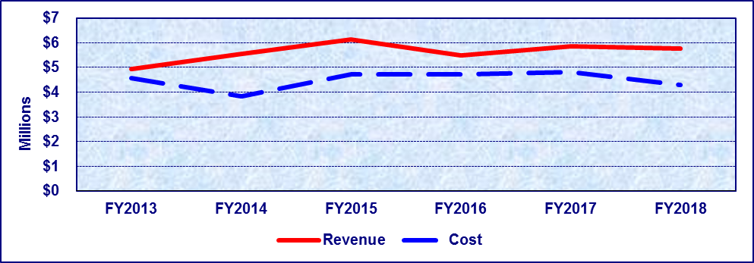
Fiscal Year | FY2013 | FY2014 | FY2015 | FY2016 | FY2017 | FY2018
Revenue | $4,922,506 | $5,560,605 | $6,124,711 | $5,482,540 | $5,843,660 | $5,770,135
Cost | $4,574,723 | $3,837,748 | $4,736,403 | $4,736,741 | $4,811,528 | $4,303,258
Percentage | 100.00% | 100.00% | 100.00% | 100.00% | 100.00% | 100.00%
*Revenue for FY2015 and FY2016 reflect corrected amounts that differ from the revenue in the FY2016 and FY2017 Fee Resource Manuals.
**Costs for FY2016 reflect corrected amounts that differ from the cost in the FY2016 Fee Resource Manual.

Detailed Fee Schedule

Vital Statistics
Type | Amount
Certified Copy of Birth Record (Texas Online) | $12 (VSS)
Certified Copy of Birth Record (Mail-In/Lobby) | $10 (VSS Reserve)  $12 (VSS)
Additional Copies of Certified Birth Record (Texas Online) | $12 (VSS)
Additional Copies of Certified Birth Record (Mail-In/Lobby) | $10 (VSS Reserve)  $12 (VSS)
Certified Copy of Death Record (Texas Online) | $10 (VSS Reserve)  $1 (VSS)
Certified Copy of Death Record (Mail-In/Lobby) | $10 (VSS Reserve)  $10 (VSS)
Additional Copies of Certified Death Record (Mail-In/ Lobby) | $3 (VSS)
Electronically filed Death Certificates (DCOA)  To file a death certificate electronically at least 1 copy must be ordered | $10 (VSS Reserve)  $1 VSS
Additional Copies of Certified Death Record (Texas Online) (DCOA) | $.55 (VSS Reserve) (VSS - No Share)
Death Certification Letter (Texas Online) | $10 (VSS)
Death Certification Letter (Mail-In-Lobby) | $10 (VSS Reserve)  $10 (VSS)
Search for Birth Record with no record found (Texas Online) | $12 (VSS)
Search for Birth Record with no record found (Mail-In/Lobby) | $22 (VSS)
Search for Death Record with no record found (Texas Online) | $10 (VSS)
Search for Death Record with no record found (Mail-In/Lobby) | $20 (VSS)
Amendments to Complete Birth or Death Records | $15 (VSS)
Amendments based on Court Order or Name Change | $15 (VSS)
New Birth Record Based on Adoption, Legitimation, or Paternity | $25 (VSS)
Filing Delayed Record of Birth | $25 (VSS)
Expedited Services | $ 5 (VSS)
Disinterment Permit | $25 (VSS)
Heirloom Birth Certificate (Texas Online) | $25 (SWEEP)  $25 (Immunizations)
Heirloom Birth Certificate (Mail-In/Lobby) | $10 (VSS Reserve)  $25 (SWEEP)  $25 (Immunizations)
Heirloom Birth Certificate if record not found (Texas Online) | $10 + $2 surcharge each
Heirloom Birth Certificate if record not found (Mail-In/ Lobby) | $20 + $2 surcharge each
Wedding Anniversary Certificate (Texas Online) | $50 to (Immunizations)
Wedding Anniversary Certificate (Mail-In/Lobby) | $10 (VSS)  $50 (Immunizations)
Central Adoption Registry (See FC§ 162.411 of this title) | $30 (VSS)
Voluntary Adoption Registry Fees (See FC§ 1086 of this title) | $15 (VSS)
Adoption Revocation | $25 (VSS)
Open a Sealed File | $10 (VSS)
Paternity Registry Letter | $10 (VSS)
Identify of Court | $10 (VSS)
Birth Verification Letter (Texas Online) | $12 (VSS)
Birth Verification Letter (Mail-In/Lobby) | $10 (VSS Reserve) $12 (VSS)
Marriage/Divorce Verification Letter (Texas Online) | $10 (VSS)
Marriage/Divorce Verification Letter (Mail-In/Lobby) | $10 (VSS)  $10 (Reserve)
Marriage/Divorce Search No Record Found (Texas Online) | $10 (VSS)
Marriage/Divorce Search No Record Found (Mail-In/Lobby) | $10 (VSS)  $10 (VSS Reserve)

General Revenue Accounts

Abusable Volatile Chemical Permit
Date of Origin: | 1987 by H.B. 173, ch. 753, 70th Leg., R.S.
Statutory Authority: | H&SC §§ 485.013 (Fees)
Texas Administrative Code Reference: | 25 T.A.C. §§ 205.54, 205.57
Fee Set By: | Rule
Fee Capped: | No
Description: | Permit fee for retailers of abusable volatile chemicals for each location at which abusable volatile chemicals may be sold.
Note: | Amended 2001 by H.B. 2950, Ch. 1463, 77th Leg., R.S.; Amended by: Acts 2015, 84th Leg., R.S., Ch. 1 (S.B. 219), Sec. 3.1244, eff. April 2, 2015.
Date Due: | Before commencing business and biennially thereafter.
Deposited To: | General Revenue Fund No. 0001, Revenue Code 312300.
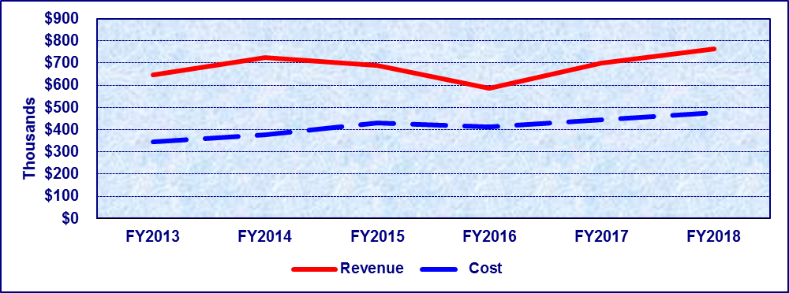
Fiscal Year | FY2013 | FY2014 | FY2015 | FY2016 | FY2017 | FY2018
Revenue | $644,873 | $723,577 | $689,145 | $587,535 | $698,999 | $763,857
Cost | $344,377 | $377,198 | $428,882 | $413,894 | $444,593 | $476,901
Percentage | 100.00% | 100.00% | 100.00% | 100.00% | 100.00% | 100.00%
*Cost for FY2017 reflects corrected amount that differs from the cost in the FY2017 Fee Resource Manual.

Detailed Fee Schedule

Abusable Volatile Chemical Permit
Type | Amount | Period
Initial Fee (For Each Retail Location) | $55 | Two Years
Renewal Fee (For Each Retail Location) | $55 | Two Years

Bloodborne Pathogen
Date of Origin: | 1999 by the 76th Leg.
Statutory Authority: | H&SC § 81.307 (Fees).
Texas Administrative Code Reference: | 25 T.A.C. §§ 96.302-304.
Fee Set By: | Rule
Fee Capped: | No
Description: | Fees to register needleless systems and sharps with engineered sharps injury protection that are available in the commercial marketplace.
Note: | Amended in 2006 to be in compliance with HB 2292, 78th Legislature, Regular Session, 2003, §2.42, added Health and Safety Code, §12.0112, which requires that the term for licenses issued or renewed after January 1, 2005, will be two years; Amended by: Acts 2015, 84th Leg., R.S., Ch. 1 (S.B. 219), Sec. 3.0249, eff. April 2, 2015.
Date Due: | At time of application and at renewal.
Deposited To: | General Revenue Fund No. 0001, Revenue Code 356212.
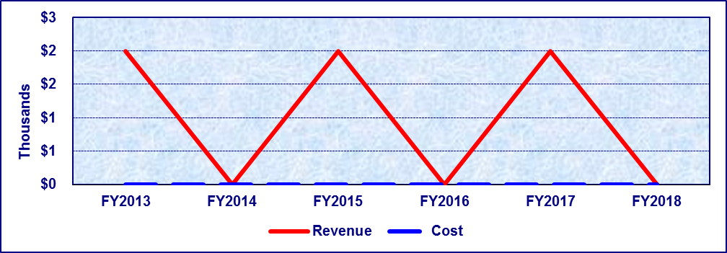
Fiscal Year | FY2013 | FY2014 | FY2015 | FY2016 | FY2017 | FY2018
Revenue | $2,000 | $0 | $2,000 | $0 | $2,000 | $0
Cost | $0 | $0 | $0 | $0 | $0 | $0
Percentage | 100.00% | 100.00% | 100.00% | 100.00% | 100.00% | 100.00%
*Revenue fluctuates due to two-year license period.

Detailed Fee Schedule

Bloodborne Pathogen
Type | Amount | Period
Initial Registration Fee | $2,500 | Two Year
Renewal Registration Fee | $2,000 | Two Year

Body Piercing
Date of Origin: | 1999 by S.B. 0061, 76th Leg., R.S.
Statutory Authority: | H&SC § 12.0111 & 146.005 (Fees)
Texas Administrative Code Reference: | 25 T.A.C. § 229.403 (Fee)
Fee Set By: | Rule
Fee Capped: | No
Description: | Fees charged to a person conducting, operating, or maintaining a body-piercing studio.
Note: | Amended by S.B. 1317, 78th Leg., R.S.; Amended by Acts 2015, 84th Leg., R.S., Ch. 1 (S.B. 219), Sec. 3.0445, eff. April 2, 2015.
Date Due: | At time of application or biennial renewal.
Deposited To: | General Revenue Fund No. 0001, Revenue Code 318009.
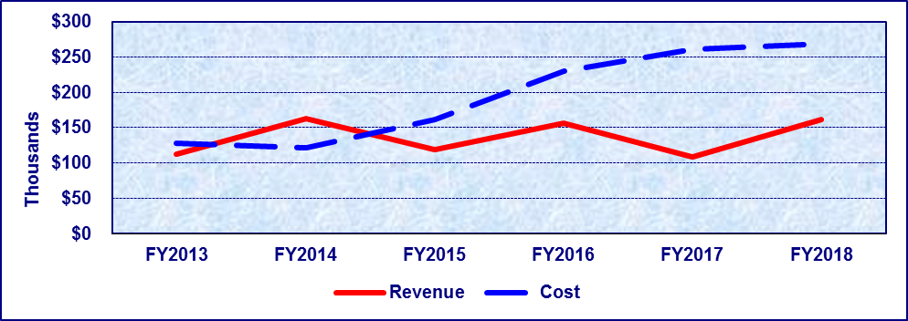
Fiscal Year | FY2013 | FY2014 | FY2015 | FY2016 | FY2017 | FY2018
Revenue | $112,327 | $163,059 | $118,326 | $156,744 | $108,614 | $161,113
Cost | $128,185 | $121,765 | $161,716 | $229,960 | $260,936 | $268,436
Percentage | 87.63% | 100.00% | 73.17% | 68.16% | 41.62% | 60.02%
*Cost for FY2017 reflects corrected amount that differs from the cost in the FY2017 Fee Resource Manual.

Detailed Fee Schedule

Body Piercing
Type | Amount | Period
Initial License Fee (Body Piercing Only) | $400 | Two Years
Renewal License Fee (Body Piercing Only) | $400 | Two Years
Temporary Location License Fee (Body Piercing Only) | $200 | Not to Exceed 7 Consecutive Days
Minor Amendment Fee (Body Piercing Only) | $200 | Per Occurrence
Initial License Fee (In Conjunction with Tattoo License) | $300 | Two Years
Renewal License Fee (In Conjunction with Tattoo License) | $300 | Two Years
Temporary Location License Fee (In Conjunction with Tattoo License) | $150 | Not to Exceed 7 Days
Minor Amendment Fee (In Conjunction with Tattoo License) | $150 | Per Occurrence
Late Fee | $100

Food, Drug, Device & Cosmetic Salvage
Date of Origin: | 1983 by H.B. 1685, 68th Leg., R.S.
Statutory Authority: | H&SC §§ 12.0111, 432.009 (Fees)
Texas Administrative Code Reference: | 25 T.A.C. §§ 229.546 (Food Salvage), 229.576 (Drug Salvage), 229.606 (Device Salvage), 229.636 (Cosmetic Salvage)
Fee Set By: | Rule
Fee Capped: | No
Description: | Licensing fee charged for regulation of salvage brokers or salvage establishments for food, drugs, devices or cosmetics. A salvage broker engages in the selling, distributing, or trafficking of distressed or salvaged merchandise but does not operate a salvage establishment. A salvage establishment is a place of business engaging in reconditioning distressed merchandise, or that buys, sells, or distributes salvaged merchandise for human use.
Note: | Amended by Acts 1989, ch 678, §1, 71st Leg. (HB 2136); Amended by Acts 2015, 84th Leg., R.S., Ch. 1 (S.B. 219), Sec. 3.1016, eff. April 2, 2015.
Date Due: | At time of initial application or biennial renewal.
Deposited To: | General Revenue Fund No. 0001, Revenue Code 355402.
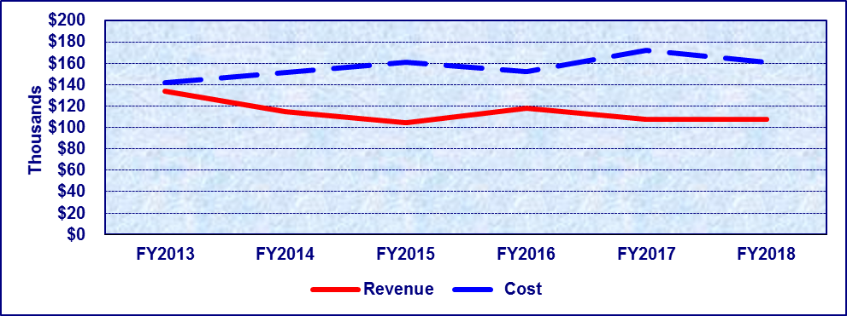
Fiscal Year | FY2013 | FY2014 | FY2015 | FY2016 | FY2017 | FY2018
Revenue | $133,560 | $114,795 | $104,466 | $118,222 | $107,271 | $107,921
Cost | $141,908 | $151,661 | $161,025 | $152,033 | $167,035 | $160,961
Percentage | 94.12% | 75.69% | 64.88% | 77.76% | 64.22% | 67.05%
*Cost for FY2017 reflects corrected amount that differs from the cost in the FY2017 Fee Resource Manual.

Detailed Fee Schedule

Food, Drug, Device, & Cosmetic Salvage
Type | Amount | Period
License Fee | $1,200 | Two Years
License Amendment Fee | $600 | Per Occurrence
Re-inspection Fee | $600 | Per Occurrence
Late Fee | $100

Food Manager Certification
Date of Origin: | 2001 by H.B. 251, 77th Leg., R.S.
Statutory Authority: | H&SC §§ 12.0111, 437.0056, 438.106 (Fees)
Texas Administrative Code Reference: | 25 T.A.C. § 229.176 (Fees)
Fee Set By: | Rule
Fee Capped: | No
Description: | Fees charged for the number of sites at which the certified food manager (CFM) licensee administers the CFM examinations. Fees include examination location sites.
Note: | Amended 2007 by H.B. 1064, 80th Leg. R.S.; Amended by: Acts 2015, 84th Leg., R.S., Ch. 1 (S.B. 219), Sec. 3.1140, eff. April 2, 2015.
Date Due: | At time of application or biennial renewal.
Deposited To: | General Revenue Fund No. 0001, Revenue Code 356213.
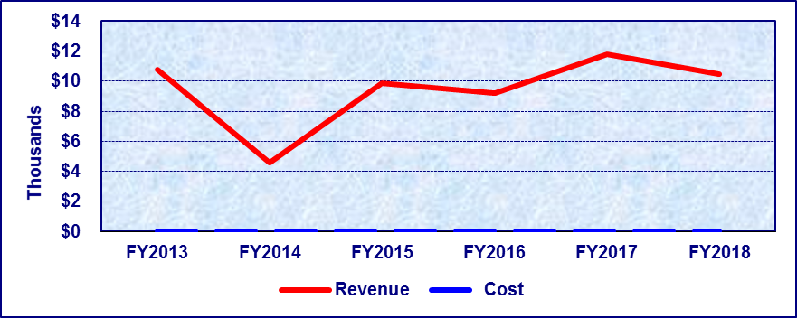
Fiscal Year | FY2013 | FY2014 | FY2015 | FY2016 | FY2017 | FY2018
Revenue | $10,767 | $4,600 | $9,900 | $9,200 | $11,800 | $10,500
Cost | $0 | $0 | $0 | $0 | $0 | $0
Percentage | 100.00% | 100.00% | 100.00% | 100.00% | 100.00% | 100.00%

Detailed Fee Schedule

Food Manager Certification
Type | Amount | Period
One Examination Location Site | $400 | Two Years
One Examination Location Site – Amended License | $200 | Per Occurrence
Two to Ten Examination Location Sites | $1,000 | Two Years
Two to Ten Examination Location Sites – Amended License | $500 | Per Occurrence
Over Ten Examination Location Sites | $2,000 | Two Years
Over Ten Examination Location Sites – Amended License | $1,000 | Per Occurrence
Late Fee | $100

Food Service Handler Certification
Date of Origin: | 1987 by H.B. 2092, 70th Leg., R.S.
Statutory Authority: | H&SC § 438.047 (Fees).
Texas Administrative Code Reference: | 25 T.A.C. § 229.178 (Fees)
Fee Set By: | Rule
Fee Capped: | No
Description: | Fees charged for the accreditation of education and training programs for persons employed in the food service industry. Fees include application and audit fees to applicants. Effective 4/24/2008, includes accreditation of Food Handler Education/Training Programs in addition to Food Manager Education/Training.
Note: | Amended 2007 by H.B. 1064, 80th Leg. R.S.; Amended 2007 by H.B. 552, 80th Leg. R.S.; Amended by: Acts 2015, 84th Leg., R.S., Ch. 1 (S.B. 219), Sec. 3.1137, eff. April 2, 2015.
Date Due: | At time of application or renewal.
Deposited To: | General Revenue Fund No. 0001, Revenue Code 314200.
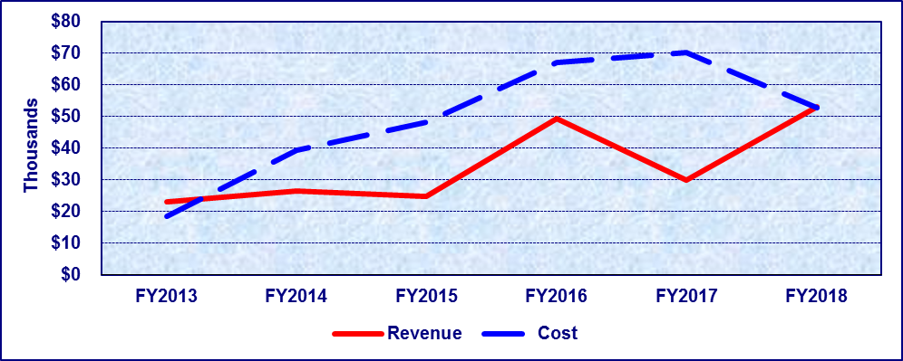
Fiscal Year | FY2013 | FY2014 | FY2015 | FY2016 | FY2017 | FY2018
Revenue | $23,065 | $26,555 | $24,725 | $49,512 | $30,000 | $53,210
Cost | $18,441 | $39,332 | $48,214 | $67,036 | $67,887 | $52,809
Percentage | 100.00% | 67.52% | 51.28% | 73.86% | 44.19% | 100.00%
*Cost for FY2017 reflects corrected amount that differs from the cost in the FY2017 Fee Resource Manual.

Detailed Fee Schedule

Food Service Handler Certification
Type | Amount | Period
Initial Application Fee | $600 | Two Years
Renewal Fee | $600 | Two Years
Amended Fee | $300 | Per Occurrence
Late Fee | $100

Frozen Desserts
Date of Origin: | 1981 by H.B. 1107, 67th Leg., R.S.
Statutory Authority: | H&SC §§12.0111, 440.013 (Fees)
Texas Administrative Code Reference: | 25 T.A.C. § 217.91 (Fees)
Fee Set By: | Rule
Fee Capped: | No
Description: | Fees charged to any person desiring to operate an establishment for the manufacture of a frozen dessert, imitation frozen dessert, or mix of one of those products for the specific purpose of wholesaling the product. The establishment must be inspected before the license is issued.
Note: | Amended by S.B. 404, 72nd Leg., R.S. (1991); Amended by Acts 2015, 84th Leg., R.S., Ch. 1 (S.B. 219), Sec. 3.1152, eff. April 2, 2015.
Date Due: | At time of application or renewal.
Deposited To: | General Revenue Fund No. 0001, Revenue Code 355410.
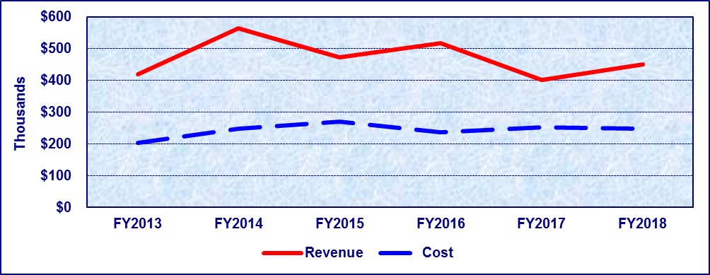
Fiscal Year | FY2013 | FY2014 | FY2015 | FY2016 | FY2017 | FY2018
Revenue | $419,108 | $562,929 | $473,192 | $517,922 | $401,558 | $450,399
Cost | $203,029 | $247,131 | $270,921 | $235,761 | $243,138 | $244,892
Percentage | 100.00% | 100.00% | 100.00% | 100.00% | 100.00% | 100.00%
*Cost for FY2017 reflects corrected amount that differs from the cost in the FY2017 Fee Resource Manual.

Detailed Fee Schedule

Frozen Desserts
Type | Amount | Period
In-State Initial Permit Fee for Each Establishment | $800 | Two Years
In-State Initial Pro-Rated Fee for Each Establishment | $600 | One Year
In-State Amended License Fee | $400 | Per Occurrence
In-State Renewal Permit Fee for Each Establishment | $800 | Two Years
Manufacturer Fee (Located In Texas) | $0.015 Per 100 lbs ($5 Minimum) of Frozen Dessert Manufactured or Processed Monthly | Monthly
Manufacturer Fee (Located Outside Texas) | $0.015 Per 100 lbs ($5 Minimum) of Frozen Dessert Manufactured or Processed and Imported for Sale in Texas Monthly | Monthly
Analyzing Samples Fee (for a Manufacturer Not Located in Texas) | Actual Cost
Late Renewal | $100

Hazardous Products Manufacturing
Date of Origin: | 1985 by H.B. 1593, ch. 239, 69th Leg., R.S.
Statutory Authority: | H&SC §§ 12.0111, 501.024, 501.026 (Fees)
Texas Administrative Code Reference: | 25 T.A.C. § 205.44 (Fees)
Fee Set By: | Rule
Fee Capped: | No
Description: | Registration fee for manufacturers whose products are distributed in Texas; may not manufacture or distribute a hazardous substance unless there is a registration statement.
Note: | Amended 2001 by S.B. 1045, ch. 360 77th Leg. R.S.; Amended by Acts 2015, 84th Leg., R.S., Ch. 1 (S.B. 219), Sec. 3.1269, eff. April 2, 2015.
Date Due: | Before commencing business and biennially thereafter.
Deposited To: | General Revenue Fund No. 0001, Revenue Code 355500.
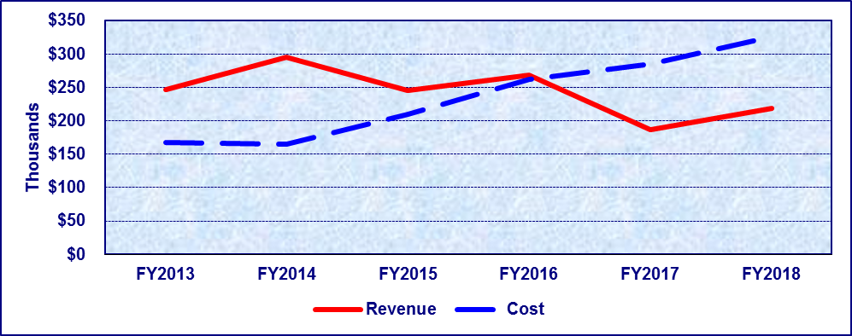
Fiscal Year | FY2013 | FY2014 | FY2015 | FY2016 | FY2017 | FY2018
Revenue | $246,596 | $294,627 | $245,413 | $268,120 | $186,763 | $218,072
Cost | $167,921 | $164,503 | $209,982 | $262,519 | $285,390 | $325,656
Percentage | 100.00% | 100.00% | 100.00% | 100.00% | 65.44% | 66.96%
*Cost for FY2017 reflects corrected amount that differs from the cost in the FY2017 Fee Resource Manual.

Detailed Fee Schedule

Hazardous Products Manufacturing
Type | Amount | Period
Initial Fee | $630 | Two Years
Annual Renewal Fee | $630 | Two Years

Insurance Notification/HIV
Date of Origin: | 1989 by H.B. 2608, 71st Leg., R.S.
Statutory Authority: | TEX. INS. CODE ANN. § 545.055 (Fees)
Texas Administrative Code Reference: | 25 T.A.C. § 97.139 (Fees)
Fee Set By: | Rule
Fee Capped: | Yes
Description: | An applicant for insurance must be given written notice of a positive HIV-related test result by a physician designated by the applicant or, in the absence of that designation, by the Department of State Health Services. The insurer shall pay the Department a fee of $25 to cover the cost of the Department providing the written notice to the applicant for insurance.
Date Due: | At time of request for notification.
Deposited To: | General Revenue Fund No. 0001, Revenue Code 372400.
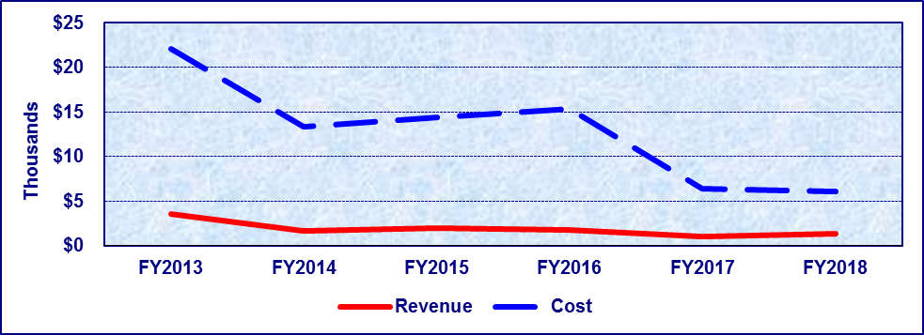
Fiscal Year | FY2013 | FY2014 | FY2015 | FY2016 | FY2017 | FY2018
Revenue | $3,525 | $1,675 | $1,925 | $1,725 | $1,050 | $1,325
Cost | $22,089 | $13,400 | $14,382 | $15,364 | $6,435 | $6,129
Percentage | 15.96% | 12.50% | 13.38% | 11.23% | 16.32% | 21.62%

Detailed Fee Schedule

Insurance Notification/HIV
Type | Amount
Request for Notification | $25 for Each Notification

Lead-Based Paint Certification Program
Date of Origin: | 1995 by S.B. 544, ch. 332, 74th Leg., R.S.
Statutory Authority: | TEXAS OCCUPATIONS CODE, §§ 1955.053, 1955.055, 1955.057, 1955.058 (Fees)
Texas Administrative Code Reference: | 25 T.A.C. §§ 295.204, 295.206 – 295.211 (Fees)
Fee Set By: | Rule
Fee Capped: | No
Description: | Notification, examination, accreditation and certification fees charged to individuals and firms engaged in lead-based paint activities in target housing or a public area that the department determines creates a public health hazard.
Note: | Amended 1997 by H.B. 729, ch. 288, 75th Leg., R.S.; Amended by: Acts 2015, 84th Leg., R.S., Ch. 1 (S.B. 219), Sec. 5.287, eff. April 2, 2015.
Date Due: | Accreditation and certification - upon application/renewal. Notification fees - upon being invoiced.  Certification replacement fees – upon application for replacement.  Examination fees - upon application for examination.
Deposited To: | General Revenue Fund No. 0001, Revenue Codes 318006 and 318011.
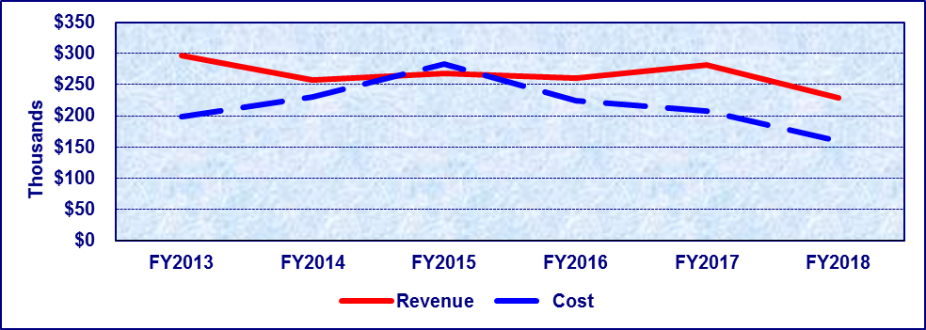
Fiscal Year | FY2013 | FY2014 | FY2015 | FY2016 | FY2017 | FY2018
Revenue | $296,273 | $257,129 | $268,246 | $260,320 | $281,237 | $229,227
Cost | $198,577 | $229,532 | $282,436 | $224,745 | $207,857 | $159,324
Percentage | 100.00% | 100.00% | 94.98% | 100.00% | 100.00% | 100.00%
*Cost for FY2017 reflects corrected amount that differs from the cost in the FY2017 Fee Resource Manual.

Detailed Fee Schedule

Lead-Based Paint Certification Program
Type | Amount | Period
Inspector – Initial and Renewal | $300 | Two Years
Notification Fee | $100 | Per Occurrence
Risk Assessor – Initial and Renewal | $600 | Two Years
Lead Abatement Supervisor – Initial and Renewal | $300 | Two Years
Lead Project Designer – Initial and Renewal | $600 | Two Years
Worker – Initial and Renewal | $100 | Two Years
Firm – Initial and Renewal | $1,000 | Two Years
Training Program Provider Accreditation– Initial and Renewal | $1,000 | Two Years
Add Training Program Provider Course to Accredited Training Program Provider | $100 | Per Occurrence
Administrative Fee for Refund | $25
Exam Fees – Inspector | $50 | Per Occurrence
Exam Fees – Risk Assessor | $50 | Per Occurrence
Exam Fees – Lead Abatement Supervisor | $50 | Per Occurrence
Replace ID Card | $20 | Per Occurrence
Replace Certificate | $20 | Per Occurrence
Late Fees All Lead License Renewals – Up to 90 Days | 1½ Times the Renewal Fee
Late Fees All Lead License Renewals – 91 Days to Less Than One Year | 2 Times the Renewal Fee

Meat Inspection
Date of Origin: | 1989 by 71st Leg. R.S., ch. 678 (HB 2136) 1999.
Statutory Authority: | H&SC § 433.009 (Fees)
Texas Administrative Code Reference: | 25 T.A.C. §§ 221.3, 221.12 (Fees)
Fee Set By: | Rule
Fee Capped: | No
Description: | Special fees for inspection services. Fees for inspection services provided to State granted meat and/or poultry slaughter and/or processing establishments that work under inspection on a holiday or on an overtime basis; and/or, fees inspection services provided to State granted establishments in relation to the inspection of animals, birds, or products that are not regulated under either the Federal Meat Inspection Act or the Federal Poultry Products Inspection Act.
Note: | Amended by H.B. 2122, 70th Leg., R.S. (1991); Amended by Acts 2015, 84th Leg., R.S., Ch. 1 (S.B. 219), Sec. 5.287, eff. April 2, 2015.
Date Due: | 30 days after inspection services are provided.
Deposited To: | General Revenue Fund No. 0001, Revenue Code 341400.
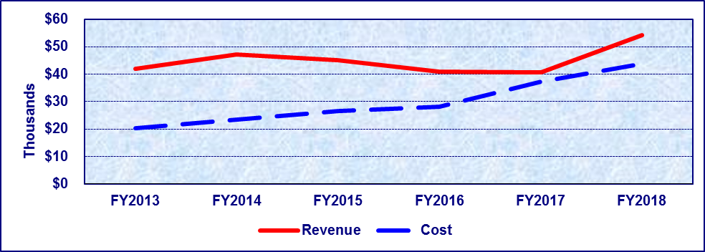
Fiscal Year | FY2013 | FY2014 | FY2015 | FY2016 | FY2017 | FY2018
Revenue | $41,824 | $47,260 | $45,082 | $40,839 | $40,741 | $54,157
Cost | $20,163 | $23,393 | $26,487 | $28,141 | $35,963 | $43,671
Percentage | 100.00% | 100.00% | 100.00% | 100.00% | 100.00% | 100.00%
*Cost for FY2017 reflects corrected amount that differs from the cost in the FY2017 Fee Resource Manual.

Detailed Fee Schedule

Meat Inspection
Type | Amount
Overtime and Holiday Rate for Inspection Services Provided Pursuant to Health and Safety Code, Chapter 433, § 433.009 | $29.50 Per Hour Per Program Employee
Rate for Inspections Not Required By or Federal Meat and Poultry Inspection Laws Provided Pursuant to Health and Safety Code, Chapter 433, § 433.009 | $29.50 Per Hour Per Program Employee

Milk Industry Products
Date of Origin: | 1979 by S.B. 315, 66th Leg.
Statutory Authority: | H&SC §§ 12.0111, 435.009 (Fees)
Texas Administrative Code Reference: | 25 T.A.C. § 217.91 (Fees)
Fee Set By: | Statute and Rule
Fee Capped: | Yes
Description: | Permit fees shall be levied on persons engaging in the movement, distribution, or sale of milk or milk products.
Note: | Amended by Acts 1997, H.B. 1875, 75th Leg., R.S. S.B. 1714, 80th Leg., R.S. (2007);  Amended by Acts 2015, 84th Leg., R.S., Ch. 1 (S.B. 219), Sec. 5.287, eff. April 2, 2015.
Date Due: | At time of application or annual renewal (on or before September 1). Monthly fees based on volume of product produced. Fees may be assessed monthly, quarterly, semi-annual, or annual basis.
Deposited To: | General Revenue Fund No. 0001, Revenue Code 340000.
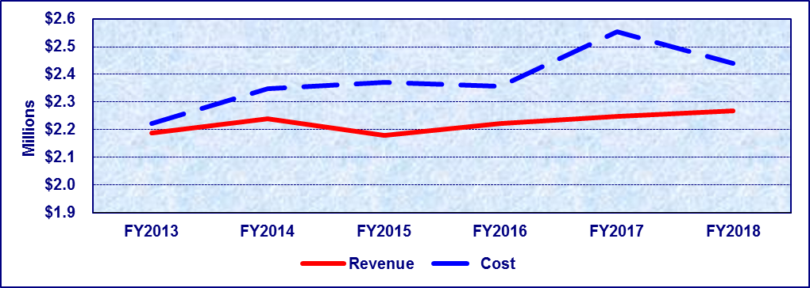
Fiscal Year | FY2013 | FY2014 | FY2015 | FY2016 | FY2017 | FY2018
Revenue | $2,188,377 | $2,240,373 | $2,179,994 | $2,221,885 | $2,248,210 | $2,269,623
Cost | $2,222,351 | $2,347,980 | $2,371,345 | $2,356,206 | $2,553,098 | $2,440,917
Percentage | 98.47% | 95.42% | 91.93% | 94.30% | 88.06% | 92.98%
*Cost for FY2015 reflects corrected amount that differs from the cost in the FY2015 Fee Resource Manual.
**Cost for FY2017 reflects corrected amount that differs from the cost in the FY2017 Fee Resource Manual.

Detailed Fee Schedule

Milk Industry Products

Milk Processing Plant
Type | Amount | Period
New (Initial) Milk Processing Plant Fee | $800 | Two Years
New (Initial) Pro-Rated Milk Processing Plant Fee | $600 | One Year
Amended License Fee | $400 | Per Occurrence
Renewal Milk Processing Plant Fee | $800 | Two Years

Producer Dairy Farm
Type | Amount | Period
New (Initial) Producer Dairy Farm Fee | $200 | Two Years
New (Initial) Pro-Rated Producer Dairy Farm Fee | $150 | One Year
Amended License Fee | $100 | Per Occurrence
Renewal Producer Dairy Farm Fee | $200 | Two Years

Transfer/Receiving Station
Type | Amount | Period
New (Initial) Transfer/Receiving Station Fee | $800 | Two Years
New (Initial) Pro-Rated Transfer/Receiving Station Fee | $600 | One Year
Amended Fee | $400 | Per Occurrence
Renewal Transfer/Receiving Station Fee | $800 | Two Years

Milk Transport Tanker Fee
Type | Amount | Period
New (Initial) Milk Transport Tanker Fee | $200 | Two Years
New (Initial) Pro-Rated Milk Transport Tanker Fee | $150 | One Year
Amended Fee | $100 | Per Occurrence
Renewal Milk Transport Tanker Fee | $200 | Two Years

Grade A Retail for Raw
Type | Amount | Period
New (Initial) Grade A Retail for Raw Fee | $800 | Two Years
New (Initial) Pro-Rated Grade A Retail for Raw Fee | $600 | One Year
Amended Fee | $400 | Per Occurrence
Renewal Non Grade-A Retail for Raw Fee | $800 | Two Years

Non Grade A Dairy Products
Type | Amount | Period
New (Initial) Non Grade-A Dairy Product Fee | $800 | Two Years
New (Initial) Pro-Rated Non Grade-A Dairy Product Fee | $600 | One Year
Amended Fee | $400 | Per Occurrence
Renewal Non Grade-A Dairy Product Fee | $800 | Two Years
Inspection Fee (Processing or Bottling Plant Located In Texas) | $0.045 Per 100 lbs of Milk ($5 Minimum) | Monthly
Inspection Fee (Non Grade-A Dairy Product Fee Located in Texas) | $0.015 Per 100 lbs ($5 Minimum) of Non Grade-A Products Manufactured or Processed Monthly | Monthly

Other Fees
Type | Amount
Milk or Milk Products Analysis Fee (Processing or Bottling Not Located in Texas) | Actual Cost
Late Renewal | $100

Radiation Materials/Radiation Devices/Fixed Nuclear Facilities
Date of Origin: | 1981 by S.B. 480, S.B. 735, 67th Leg., R.S.
Statutory Authority: | H&SC §§ 401.301, 401.302 (Fees)
Texas Administrative Code Reference: | 25 T.A.C. §§ 289.204 (Fees) and 289.255 (Radiographer Certification and Examination Fees)
Fee Set By: | Rule
Fee Capped: | No
Description: | Licenses or registrations required of persons who use, manufacture, produce, transport, transfer, acquire, own, possess or dispose of any non-exempt source of radiation.
Note: | Amended 2001 by H.B. 1099, 77th Leg. R.S.; 2007 by H.B. 2285 and S.B. 1604, 80th Leg., R.S.; 2013 by S.B. 347, 83rd Leg., R.S.; Amended by: Acts 2015, 84th Leg., R.S., Ch. 1 (S.B. 219), Sec. 3.0920, eff. April 2, 2015.
Date Due: | Determined by Rule.
Deposited To: | General Revenue Fund No. 0001, Revenue Code 358900.
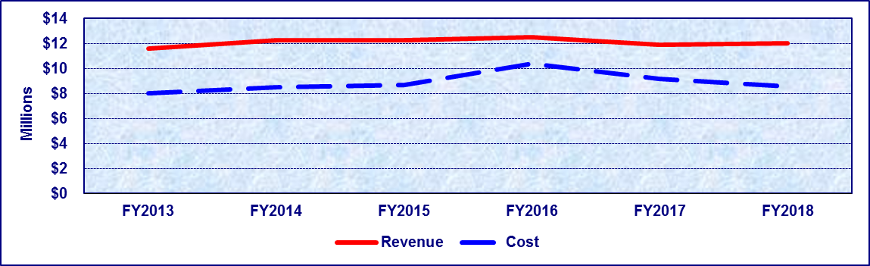
Fiscal Year | FY2013 | FY2014 | FY2015 | FY2016 | FY2017 | FY2018
Revenue | $11,616,110 | $12,276,819 | $12,228,083 | $12,511,054 | $11,875,565 | $11,994,924
Cost | $8,000,427 | $8,495,740 | $8,705,598 | $10,396,889 | $9,154,141 | $8,575,364
Percentage | 100.00% | 100.00% | 100.00% | 100.00% | 100.00% | 100.00%
*Cost for FY2017 reflects corrected amount that differs from the cost in the FY2017 Fee Resource Manual.

Detailed Fee Schedule

Radiation Materials/Radiation Devices/Fixed Nuclear Facilities

Radioactive Materials
Type | Amount | Period
Accelerator (Used for Production of Radioactive Material) | $17,620 | Two Years
Agency-Accepted Training Course (Involving Possession of Radioactive Material) | $4,230 | Two Years
Bone Mineral Analyzer | $2,290 | Two Years
Broad License | $23,810 | Two Years
Calibration Service (Survey Instrument) | $1,950 | Two Years
Calibration/Reference Source | $1,460 | Two Years
Decontamination Service Fixed Site | $29,440 | Two Years
Decontamination Service Mobile | $9,650 | Two Years
Demonstration/Sales | $4,410 | Two Years
Environmental Laboratory | $1,800 | Two Years
Eye Applicator | $1,800 | Two Years
Fee Evaluation of a Device Amendment Requiring Re-Evaluation | $5,330 | By Occurrence
Fine Leak Testing Device | $5,540 | Two Years
Fixed Multi-Beam Teletherapy | $9,910 | Two Years
X-Ray Fluorescence | $2,290 | Two Years
Hand-held Light Intensifying Imaging Device | $2,290 | Two Years
Gas Chromatograph | $2,130 | Two Years
Gauge – Spinning Pipe Thickness Portable | $3,240 | Two Years
Gauge – Fixed | $3,410 | Two Years
General License Acknowledgement-Gauge | $1,410 | Two Years
Industrial Radiography (Fixed Facility) | $8,490 | Two Years
Industrial Radiography (Temporary Field Site) | $17,870 | Two Years
Installer, Repair, or Maintenance | $3,600 | Two Years
Irradiator (Self-Contained) | $4,690 | Two Years
Irradiator (Unshielded) | $28,900 | Two Years
In-Vitro Use of Radioactive Material | $1,090 | Two Years
In-Vitro Test Kit Manufacturer | $5,660 | Two Years
Leak Test Service | $2,130 | Two Years

Manufacturing and Commercial Distribution
Type | Amount | Period
Fee Evaluation of a Sealed Source – Initial Evaluation | $5,320 | By Occurrence
Fee Evaluation of a Sealed Source – Amendment Requiring Re-Evaluation | $2,660 | By Occurrence
Fee Evaluation of a Device – Initial Evaluation | $10,650 | By Occurrence
Fee Evaluation of a Device – Amendment Requiring Re-Evaluation | $5,330 | By Occurrence
Processor of Radioactive Material | $56,060 | Two Years
Other Manufacturing and Commercial Distribution | $9,140 | Two Years
Commercial Distribution Only | $4,230 | Two Years
Limited Manufacturing (Loose Material) | $8,160 | Two Years
Medical Therapy (Sealed Source) | $4,060 | Two Years
Medical Therapy (Unsealed Source) | $3,410 | Two Years
Mineral Recovery (Byproduct Material) | $76,930 | Two Years
Mobile Scanning Service | $5,060 | Two Years
Naturally Occurring Radioactive Material (NORM) - Commercial Processing | $29,440 | Two Years
Neutron Generator Target (Sealed) | $5,920 | Two Years
Nuclear Medicine (Diagnostic) | $3,620 | Two Years
Nuclear Pharmacy | $8,160 | Two Years
Pipe Joint Collar Marker | $2,610 | Two Years
Sealed Sources & Device – Record Maintenance Fee (Beginning One Year After Initial Sealed Source and Device Authorization Listing and Every Two Years Thereafter) | $1,000 | Annual then Biennially

Other Radioactive Materials
Type | Amount | Period
Radiopharmaceutical Manufacturing | $24,130 | Two Years
Remote Controlled Brachytherapy Device (Includes Low Dose-Rate and High Dose-Rate Remote Afterloaders and Intravenous Brachytherapy) | $5,330 | Two Years
Research and/or Development | $5,970 | Two Years
Source Material | $4,410 | Two Years
Special Nuclear Material | $2,610 | Two Years
Teletherapy | $4,080 | Two Years
Tracer Studies (Used in other than Oil and Gas Industry Wellbores) | $7,520 | Two Years
Tracer Studies (Used in Oil and Gas Industry Wellbores | $4,540 | Two Years
Well Logging | $5,920 | Two Years
Other Specific License | $2,980 | Two Years
Additional Authorized Use Sites Where Radioactive Material Is Stored Or Used Under Same License Or Where Only Records Are Stored | 25% of Applicable Fee Not To Exceed 50 Additional sites
Reciprocity | Fee of Applicable Category | Two Years

Type | Amount
An additional non-refundable fee equal to five percent of the total fee for each specific license shall be paid with the specified fee by each holder of a specific license, excluding licensees that are authorized only for diagnostic nuclear medicine licensees.  Note: The additional five percent fee for each specific license shall be deposited to the credit of the Radiation Perpetual Care Account. The agency shall collect the five percent fees so long as the sum of the balances of the perpetual care accounts specified under Health and Safety Code, § 401.307, does not exceed $100 million; and if the sum of such balances subsequently is reduced to $50 million or less, the agency shall reinstitute assessment of the fee until the sum of such balances reaches $100 million. | This Portion of the Fee is Incorporated With a Specific Fee Type and Would be Included in the TOL for That Fee Type.

Type | Amount | Period
Fee Evaluation of a Sealed Source – Initial Evaluation | $5,320 | Two Years
Fee Evaluation of a Sealed Source – Amendment Requiring Re-Evaluation | $2,660 | Two Years
Fee Evaluation of a Device – Initial Evaluation | $10,650 | Two Years
Fee Evaluation of a Device Amendment Requiring Re- Evaluation | $5,330 | Two Years
Sealed Source & Device - Record Maintenance Fee (Beginning One Year After Initial Sealed Source and Device Authorization Listing and Every Two Years Thereafter) | $1,000

Radiation Machines, Lasers, and Services
Type | Amount | Period
Computerized Tomography (CT) | $1,910 | Two Years
Fluoroscopy | $940 | Two Years
Accelerator, Simulator, or Other Therapeutic Radiation Machine | $1,910 | Two Years
Radiographic Machines Only | $600 | Two Years
Podiatric Radiographic Only | $420 | Two Years
Dental Radiographic Only | $370 | Two Years
Veterinary, Including CT, Fluoroscopy, and Accelerators | $290 | Two Years
Industrial Radiography Fixed Facility | $1,960 | Two Years
Industrial Radiography Temporary Job Sites | $3,280 | Two Years
Other Industrial – Diffraction, Computerized Tomography, Fluoroscopy, Flash Radiography and Hand-held Light Intensifying Image Devices | $670 | Two Years
Other Industrial – Diffraction, Computerized Tomography, Fluoroscopy, Flash Radiography and Hand-held Light Intensifying Image Devices | $670 | Two Years
Morgues and Educational Facilities Utilizing Radiation Machines for Non-human Use, Including CT, Fluoroscopy, and Accelerators | $670 | Two Years
Minimal Threat Radiation Machines as Specified in 25 TAC § 289.231(ll)(3) of this Title–Cathodoluminescence, Electron Beam Welding, Fluorescence X-Ray, Gauge X-Ray, Ion Implantation, Package X-Ray, Particle Size Analyzer X-Ray, Cabinet X-Ray (Certified), Other | $290 | Two Years
Exposure Rate or Dose Measurements performed by a Licensed Medical Physicist as Specified in 25 TAC § 289.226(b)(9) of Title | $290 | Two Years
Services as Specified in 25 TAC § 289.226(b)(10) of this Title – Exposure Rate or Dose Measurements, Radiation Machine Output Measurements, Agency-Accepted Training Courses, Calibration, Demonstration/Sales, Assembly, Installation or Repair, Equipment Performance Evaluations on Dental Radiation Machines, Provider of Equipment | $290 | Two Years
Laser - Medical/Research/Academic | $230 | Two Years
Laser - Industrial/Services/Entertainment | $400 | Two Years
Reciprocity | Fee of Applicable Category | Two Years
Additional Authorized Use Location Where Radiation Machines or Services are Authorized Under the Same Registration | 30% of Applicable Fee  This Portion of the Fees is Incorporated With a Specific Fee Type and Would be Included in the TOL for That Fee Type

Environmental Surveillance and Emergency Planning and Implementation
Type | Amount | Period
Fixed Nuclear Facilities | Actual Expenses for Environmental Surveillance and Emergency Planning and Implementation Activities.  Costs of Activities Benefiting More Than One Facility Shall be Prorated | Annually

Industrial Radiographer Certification and for Radiographer Certification Examinations
Type | Amount | Period
Application Fee for Examination | $120 | Per Occurrence
Application Fee for Radiographer Certification | $110 | Per Occurrence
Industrial Radiography Replacement Certification ID Card | $35 | Per Occurrence

School Cafeteria Inspections
Date of Origin: | 2004 by Public Law 108-265, 118 Stat. 747 (Child Nutrition and WIC Reauthorization Act).
Statutory Authority: | H&SC § 437.0125 (Fees).
Texas Administrative Code Reference: | 25 T.A.C. § 229.472. (Fees)
Fee Set By: | Rule
Fee Capped: | No
Description: | Fees relating to permitting and inspection of school food service establishments, or non-permitted food service establishments.
Note: | Amended by: Acts 2015, 84th Leg., R.S., Ch. 1 (S.B. 219), Sec. 3.1125, eff. April 2, 2015.
Date Due: | For school food service establishments, an application and inspection fee must be submitted between September 15 and October 31 annually.  For non-permitted food establishments, the fee must be submitted at least six weeks prior to the earliest desired inspection date.
Deposited To: | General Revenue Fund No. 0001, Revenue Code 318010.
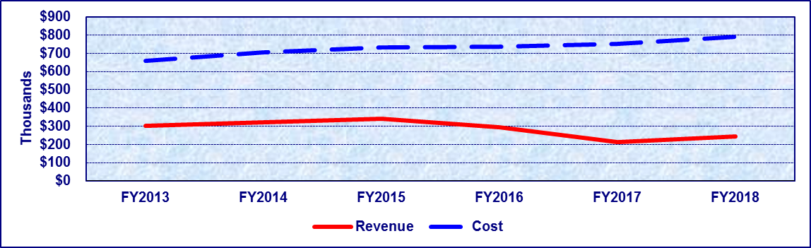
Fiscal Year | FY2013 | FY2014 | FY2015 | FY2016 | FY2017 | FY2018
Revenue | $299,989 | $322,781 | $339,844 | $292,530 | $211,320 | $243,000
Cost | $658,219 | $704,339 | $733,733 | $735,811 | $751,348 | $791,594
Percentage | 45.58% | 45.83% | 46.32% | 39.76% | 28.13% | 30.70%
*Cost for FY2017 reflects corrected amount that differs from the cost in the FY2017 Fee Resource Manual.

Detailed Fee Schedule

School Cafeteria Inspections
Type | Amount
School Food Establishments | $300 for Two Inspections Per Year

Tattoo Studios
Date of Origin: | 1993 by H.B. 1217, 73rd Leg., R.S.
Statutory Authority: | H&SC §§ 12.0111, 146.005 (Fees)
Texas Administrative Code Reference: | 25 T.A.C. §§ 229.403 (Fee)
Fee Set By: | Rule
Fee Capped: | No
Description: | A license fee to operate an establishment or facility in which tattooing is performed which includes the practice of producing an indelible mark or figure on the human body by scarring or inserting a pigment under the skin using needles, scalpels, or other related equipment.
Note: | Amended by H.B. 2402, 74th Leg., R.S.; Amended by Acts 2015, 84th Leg., R.S., Ch. 1 (S.B. 219), Sec. 3.1000, eff. April 2, 2015.
Date Due: | At time of application or biennial renewal.
Deposited To: | General Revenue Fund No. 0001, Revenue Code 318003
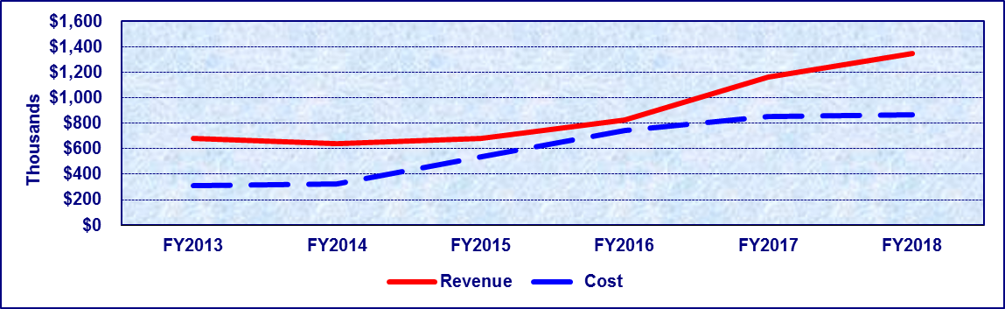
Fiscal Year | FY2013 | FY2014 | FY2015 | FY2016 | FY2017 | FY2018
Revenue | $680,309 | $640,422 | $681,734 | $825,421 | $1,163,702 | $1,345,674
Cost | $310,485 | $321,936 | $540,098 | $740,590 | $851,755 | $867,247
Percentage | 100.00% | 100.00% | 100.00% | 100.00% | 100.00% | 100.00%
*Cost for FY2017 reflects corrected amount that differs from the cost in the FY2017 Fee Resource Manual.

Detailed Fee Schedule

Tattoo Studios
Type | Amount | Period
License Fee | $900 | Two Years
License Amendment Fee | $450 | Per Occurrence
Temporary Event Fee | $450 | Maximum of 7 Consecutive Days
Late Fee | $100

Texas Health Care Information Collection (THCIC)
Date of Origin: | THCIC was created by the 74th Texas Legislature, 1995
Statutory Authority: | Texas Health and Safety Code § 108.012(b)
Texas Administrative Code Reference: | 25 T.A.C. §421(a-f)
Fee Set By: | Rule
Fee Capped: | No
Description: | THCIC's charge is to collect data and report on health care activity in hospitals and health maintenance organizations operating in Texas. The goal is to provide information that will enable consumers to have an impact on the cost and quality of health care in Texas. Fees are collected to sustain the program (HSC § 108.012(b)).
Note: | Amended by: Acts 2015, 84th Leg., R.S., Ch. 1 (S.B. 219), Sec. 3.0355, eff. April 2, 2015.
Date Due: | At time of initial application, renewal application, or per occurrence for request of data.
Deposited To: | General Revenue Fund No. 0001, Revenue Codes 372706
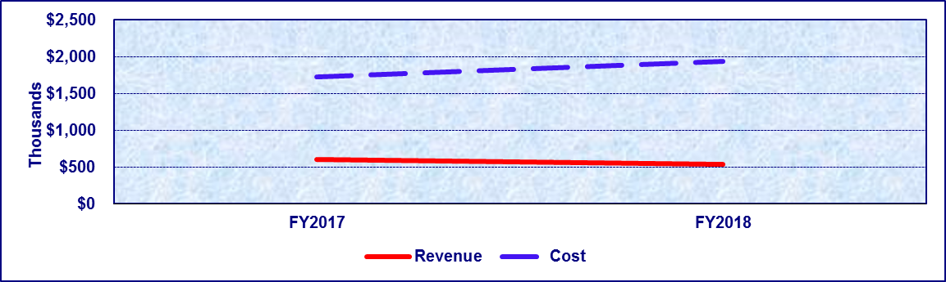
Fiscal Year | FY2017 | FY2018
Revenue | $599,920 | $535,963
Cost | $1,724,188 | $1,936,844
Percentage | 34.79% | 27.67%
*Revenue and Cost for THCIC were added to the FY2017 Fee Resource Manual, this program has been in existence since FY1999.
**Revenue for FY2017 reflects corrected amount that differs from the revenue reported in the FY2017 Fee Resource Manual

Detailed Fee Schedule

Texas Health Care Information Collection (THCIC)
Type | Amount | Period
Public Use Data Files (PUDF) - Texas state agencies or Texas state universities  Local Health Departments exempted by policy beginning August 2018 | $0 or no charge | All years
Public Use Data Files (PUDF) - Texas private universities/colleges, out-of-state media, out-of-state agencies, out-of-state universities, out-of-state hospitals and all other businesses or consumers, including hospital or Ambulatory Surgery Center affiliates, organizations, institutions, and corporate offices. | $6,000 per calendar year or $1,750 per calendar quarter. | Since January 1, 2012  Last three most current available years of data.
 | $2,500 per Calendar Year or $625 per calendar quarter. | For data four to six calendar years from the current year
 | Available at no charge from DSHS Internet Website | For data older than six years from the current year.
Public Use Data Files (PUDF) -Texas reporting hospitals, Texas in-state media, and out-of-state health departments. | $3,000 per calendar year or $1,750 per calendar quarter. | Since January 1, 2012  Last three most current available years of data.
 | $625 per calendar year or $156.25 per calendar quarter. | For data four to six calendar years from the current year.
 | Available at no charge from DSHS Internet Website | For data older than six years from the current year.
Research Data Files (RDF) – requests for data elements that are not in the PUDF. These custom datasets require DSHS Institutional Review Board (DSHS IRB) approval. All Health and Human Services Agencies | $0 or no charge | Since September 1, 2015
Research Data Files (RDF) – requests for data elements that are not in the PUDF. These custom datasets require DSHS Institutional Review Board (DSHS IRB) approval. All others except Health and Human Services Agencies | $30 per data element per calendar quarter. Additional fees may be assessed if significant work is required to extract or filter unnecessary data (to protect those patients’ identity and privacy), or link the data to another data set. The fees are based on the estimated time required multiplied by the hourly midpoint range rate of the Salary Group for Class Title "Research Specialist IV" determined by the State Auditor's Office. | Since 2012

Youth Camp Inspection
Date of Origin: | 1973 by H.B. 115, ch. 142, 63rd Leg., R.S.
Statutory Authority: | H&SC §§ 141.0035, 141.004, 141.005 and 141.0095 (Fees)
Texas Administrative Code Reference: | 25 T.A.C. §§ 265.23 and 265.28 (Fees)
Fee Set By: | Rule
Fee Capped: | Yes
Description: | Licensing fees charged to operate a facility or property, other than a facility required to be licensed by the Department of Family and Protective Services, that: (1) has the general characteristics of a day camp, resident camp, or travel camp; (2) is used primarily or partially for recreational, athletic, religious, or educational activities; and (3) accommodates at least five minors who attend or temporarily reside at the camp for all or part of at least four days.
Note: | Amended 1985 by H.B. 1593, ch. 239, 69th Leg. R.S.; 1991 by S.B. 253, ch. 251, 72nd Leg. R.S.; 2003 by H.B. 2350, ch. 1110, 78th Leg. R.S.; 2005 by S.B. 990, ch. 860, 79th Leg. R.S.; Amended by: Acts 2015, 84th Leg., R.S., Ch. 1 (S.B. 219), Sec. 3.1000, eff. April 2, 2015.
Date Due: | Initial and renewal licensure fee– upon application/renewal. Replacement certificate fee– upon application for replacement.
Deposited To: | General Revenue Fund No. 0001, Revenue Code 357302.
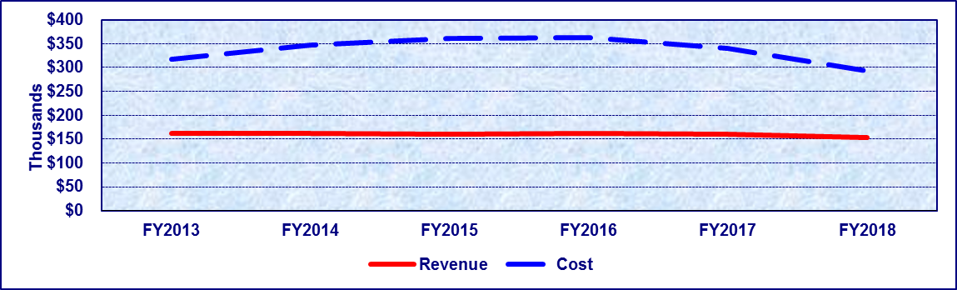
Fiscal Year | FY2013 | FY2014 | FY2015 | FY2016 | FY2017 | FY2018
Revenue | $161,517 | $161,018 | $159,582 | $162,347 | $159,365 | $152,737
Cost | $317,239 | $347,050 | $360,955 | $361,942 | $339,250 | $293,264
Percentage | 50.91% | 46.40% | 44.21% | 44.85% | 46.98% | 52.08%
*Cost for FY2017 reflects corrected amount that differs from the cost in the FY2017 Fee Resource Manual.

Detailed Fee Schedule

Youth Camp Inspection
Type | Amount | Period
Initial Day Youth Camp | $250 | One Year
Initial Residential Youth Camp | $750 | One Year
Renewal Day Youth Camps Operating Less than 10 Days per Year | $50 | One Year
Renewal Day Youth Camps Operating 10 or More Days per Year | $150 | One Year
Renewal Residential Youth Camps Operating Less than 10 Days per Year | $100 | One Year
Renewal Residential Youth Camps Operating 10 or More Days per Year | $450 | One Year
Administrative Fee for Refunds | $50
Returned Item Fee (NSF) | $20 | Per Occurrence
Name Change | $20 | Per Occurrence
Replacement Certificate | $20 | Per Occurrence

Fee Authority Not Currently Utilized

Environmental Health Officers
Date of Origin: | 1989, 71st Leg., ch. 678, Sec. 1, eff. Sept. 1, 1989. Amended by Acts 1991, 72nd Leg., ch. 597, Sec. 76, eff. Sept. 1, 1991; acts 1997, 75th Leg., ch. 742, Sec. 1, eff. June 17, 1997
Statutory Authority: | H&SC §341.082
Texas Administrative Code Reference:
Fee Set By: | Statute
Note: | Amended by: Acts 2015, 84th Leg., R.S., Ch. 1 (S.B. 219), Sec. 3.1125, eff. April 2, 2015.
Description: | If a certificate of competency as an environmental health officer were issued, an applicant or holder would be required to pay a fee of $10.00 per year. Such certificates are not issued and no fees are collected.

HIV Medication Program
Date of Origin: | Acts 1991, 72nd leg., Ch. 14, Sec. 36, eff. Sept. 1, 1991
Statutory Authority: | H&SC §85.065
Texas Administrative Code Reference:
Fee Set By: | Statute
Note: | Amended by: Acts 2015, 84th Leg., R.S., Ch. 1 (S.B. 219), Sec. 3.1125, eff. April 2, 2015.
Description: | Sliding fee scale to help eligible HIV-infected individuals purchase medications under the HIV Medication Program. This fee has not been established.

Training, Registration of HIV Counselors

Date of Origin: | 1991 by S.B. 404, 72nd Leg., R.S.
Statutory Authority: | H&SC § 85.087 (Fees)
Texas Administrative Code Reference: | 25 T.A.C. § 97.141 (Fees)
Fee Set By: | Rule
Fee Capped: | No
Note: | Amended by: Acts 2015, 84th Leg., R.S., Ch. 1 (S.B. 219), Sec. 3.1000, eff. April 2, 2015.
Description: | A training course fee assessed for persons providing HIV counseling. Employees of entities receiving state or federal funds for HIV counseling and testing programs through a contract with the department will not be charged a fee.

Revenue History

Dedicated General Revenue Fees
Fee | FY2013 Revenue | FY2014 Revenue | FY2015 Revenue | FY2016 Revenue | FY2017 Revenue | FY2018 Revenue
Asbestos Removal Licensure | $4,078,362 | $4,134,709 | $3,865,377 | $3,771,532 | $4,034,938 | $3,907,110
Emergency Medical Services | $2,202,106 | $2,306,889 | $2,278,843 | $2,341,149 | $2,314,272 | $2,673,762
Food and Drug Wholesale Distribution/ Manufacturing | $7,786,373 | $8,094,395 | $8,680,993 | $8,413,631 | $9,048,233 | $8,661,758
Food Service Establishments | $2,404,853 | $2,607,585 | $2,508,229 | $2,606,282 | $2,600,275 | $2,776,912
Low Level Radioactive Waste |  |  |  |  |  | $215,916
Mammography Systems Certification and Accreditation | $1,275,492 | $1,306,294 | $1,408,985 | $1,419,839 | $1,314,452 | $1,345,069
Medical Device Distributor and Manufacturer¹ | $818,873 | $764,307 | $809,116 | $764,694 | $891,421 | $888,560
Oyster Sales | $353,745 | $239,266 | $149,336 | $105,216 | $177,272 | $200,765
Public Health Services | $14,119,156 | $13,108,569 | $15,718,864 | $16,478,714 | $21,915,194 | $22,419,216
Vital Statistics* | $4,922,506 | $5,560,605 | $6,124,711 | $5,482,540 | $5,843,660 | $5,770,135
¹ Revenue from FY2013-FY2015 for Medical Device Distributor and Manufacturer was classified as General Revenue until FY2016 when revenue was collected under Fund 5024 and reclassified as Dedicated General Revenue.
*Includes Adoption Registry

General Revenue Fees
Fee | FY2013 Revenue | FY2014 Revenue | FY2015 Revenue | FY2016 Revenue | FY2017 Revenue | FY2018 Revenue
Abusable Volatile Chemical Permit | $644,873 | $723,577 | $689,145 | $587,535 | $698,999 | $763,857
Bloodborne Pathogen | $2,000 | $0 | $2,000 | $0 | $2,000 | $0
Body Piercing | $112,327 | $163,059 | $118,326 | $156,744 | $108,614 | $161,113
Food, Drug, Device, & Cosmetic Salvage | $133,560 | $114,795 | $104,466 | $118,222 | $107,271 | $107,921
Food Manager Certification | $10,767 | $4,600 | $9,900 | $9,200 | $11,800 | $10,500
Food Service Handler Certification | $23,065 | $26,555 | $24,725 | $49,512 | $30,000 | $53,210
Frozen Desserts | $419,108 | $562,929 | $473,192 | $517,922 | $401,558 | $450,399
Hazardous Products Manufacturing | $246,596 | $294,627 | $245,413 | $268,120 | $186,763 | $218,072
Insurance Notification/HIV | $3,525 | $1,675 | $1,925 | $1,725 | $1,050 | $1,325
Lead-Based Paint Certification Program | $ 296,273 | $257,129 | $268,246 | $260,320 | $281,237 | $229,227
Meat Inspection | $41,824 | $47,260 | $45,082 | $40,839 | $40,741 | $54,157
Milk Industry Products | $2,188,377 | $2,240,373 | $2,179,994 | $2,221,885 | $2,248,210 | $2,269,623
Radiation Materials/Radiation Devices/Fixed Nuclear Facilities | $11,616,110 | $12,276,819 | $12,228,083 | $12,511,054 | $11,875,565 | $11,994,924
School Cafeteria Inspections | $299,989 | $322,781 | $339,844 | $292,530 | $211,320 | $243,000
Tattoo Studios | $680,309 | $640,422 | $681,734 | $825,421 | $1,163,702 | $1,345,674
Texas Health Care Information Collection (THCIC) |  |  |  |  | $599,920 | $535,963
Youth Camp Inspection | $161,517 | $161,018 | $159,582 | $162,347 | $159,365 | $152,737

GR Fees No Longer Under DSHS Authority
Fee | Authority | Date Effective | Deregulated/  Transfer Agency
Abortion Facility | S.B. 200 | 9/1/2017 | HHSC
Ambulatory Surgical Centers | S.B. 200 | 9/1/2017 | HHSC
Athletic Trainers | S.B. 202 | 10/3/2016 | TDLR
Bedding Registration | S.B. 202 | 9/1/2015 | Deregulated
Birthing Centers | S.B. 200 | 9/1/2017 | HHSC
Bottled / Vended Water Operations | S.B. 202 | 9/1/2015 | Deregulated
Chemical Dependency Treatment Facilities | S.B. 200 | 9/1/2017 | HHSC
Code Enforcement Officers Registration | S.B. 202 | 9/1/2017 | TDLR
Council on Sex Offender Treatment Providers | S.B. 200 | 9/1/2017 | HHSC
Dieticians | S.B. 202 | 10/3/2016 | TDLR
Dispensing Opticians / Contact Lenses | S.B. 202 | 9/1/2015 | Deregulated
Dyslexia | S.B. 202 | 10/3/2016 | TDLR
End Stage Renal Facilities | S.B. 200 | 9/1/2017 | HHSC
Freestanding Emergency Medical Care Facility | S.B. 200 | 9/1/2017 | HHSC
Hearing Instrument Fitters and Dispensers | S.B. 202 | 10/3/2016 | TDLR
Hospital Licensing | S.B. 200 | 9/1/2017 | HHSC
Laser Hair Removal Certified Professionals, Technicians, Apprentices | S.B. 202 | 11/1/2017 | TDLR
Laser Hair Removal Facility | S.B. 202 | 11/1/2017 | TDLR
Licensed Chemical Dependency Counselors | S.B. 200 | 9/1/2017 | HHSC
Marriage and Family Therapists | S.B. 200 | 9/1/2017 | HHSC
Massage Therapists | S.B. 200 | 11/1/2017 | TDLR
Medical Physicists | S.B. 202 | 1/4/2016 | TMB
Medical Radiological Technologists | S.B. 202 | 1/4/2016 | TMB
Midwifery Training | S.B. 202 | 10/3/2016 | TDLR
Mold Assessors and Remediators | S.B. 200 | 11/1/2017 | TDLR
Narcotic Treatment Programs | S.B. 200 | 9/1/2017 | HHSC
Offender Education Program | S.B. 202 | 11/1/2017 | TDLR
Perfusionists | S.B. 202 | 1/4/2016 | TMB
Personal Emergency Response System | S.B. 202 | 9/1/2015 | Deregulated
Private Psychiatric Hospitals & Crisis Stabilization Units | S.B. 200 | 9/1/2017 | HHSC
Professional Counselors | S.B. 200 | 9/1/2017 | HHSC
Prosthetics and Orthotics | S.B. 202 | 10/3/2016 | TDLR
Pseudoephedrine Certificate of Authority | S.B. 2065 | 9/1/2017 | Deregulated
Renderer's License | S.B. 202 | 9/1/2015 | Deregulated
Respiratory Care Practitioners | S.B. 202 | 1/4/2016 | TMB
Sanitarian Registration | S.B. 202 | 11/1/2017 | TDLR
Social Workers Licensing | S.B. 200 | 9/1/2017 | HHSC
Special Care Facilities | S.B. 200 | 9/1/2017 | HHSC
Speech Language Pathologists and Audiologists | S.B. 202 | 10/3/2016 | TDLR
Tanning Facility | S.B. 202 | 9/1/2015 | Deregulated
Workplace Chemical List - Tier Two | H.B. 942 | 9/1/2015 | TCEQ

(Page Left Blank Intentionally)

