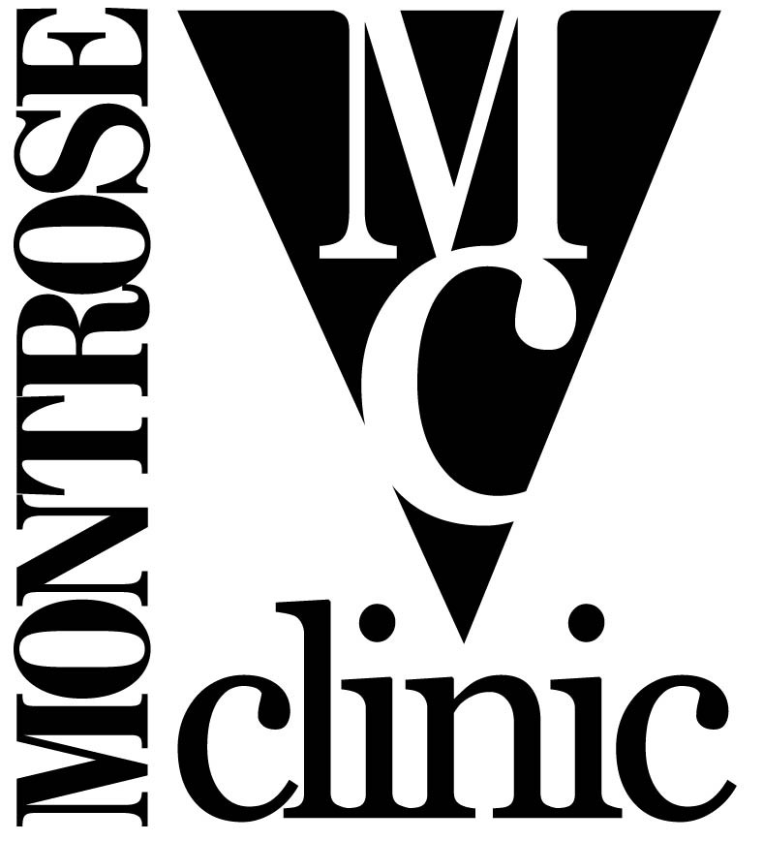
CDC 04064 RHT & PCM
Programmatic Needs Assessment

- Social Services Department
- Education Department

Survey

PURPOSE: The purpose of this survey is to assess the needs of the staff in the Social Services and Education Departments, primarily those who will be conducting prevention activities under the CDC 04064 Rapid HIV Testing and Prevention Case Management programs. Information gathered thru this survey will help establish goals for the departments and assist in developing program plans for implementation, quality assurance, and evaluation.

INSTRUCTIONS: This survey will be completed anonymously, so we ask that you please respond to questions as honestly as possible.

1. What is your position at (insert name of facility)?

- Director
- Supervisor
- Health Educator
- Prevention Case Manager
- Other: ________________

2. What encourages you to work at (insert name of facility)?

________________________________________________________________________________________________________________________________________________________________________________________________________________________________________________________________________________________________________________

3. What motivates you to deliver high quality services?

________________________________________________________________________________________________________________________________________________________________________________________________________________________________________________________________________________________________________________

4. What gets in your way of doing your best at your job?

________________________________________________________________________________________________________________________________________________________________________________________________________________________________________________________________________________________________________________

5. What is satisfying about the work that you do?

________________________________________________________________________________________________________________________________________________________________________________________________________________________________________________________________________________________________________________

6. What type of support do you receive in acquiring, maintaining, and improving your knowledge and skills? (This could be a co-worker, supervisor, yourself, or others.)

________________________________________________________________________________________________________________________________________________________________________________________________________________________________________________________________________________________________________________

7. How well do you know what is expected of you in your job?

- Not very well
- Fair
- Neutral
- Well
- Very well

8. How would you rate yourself in terms of how well you meet those expectations?

- 1 (lowest) □ 2 □ 3 □ 4 □ 5 (highest)

9. The amount of work I am expected to do on my job is reasonable.

- Strongly disagree
- Disagree
- Neutral
- Agree
- Strongly agree

10. Diverse perspectives (e.g., gender, race/ethnicity, sexual orientation, etc.) are valued and encouraged within the department.

- Strongly disagree
- Disagree
- Neutral
- Agree
- Strongly agree

SAFETY ISSUES

11. How important are these safety issues to you? (Please rank each item in order of importance with 1 being most important and 10 being least important):

___ Being in building after hours
___ Phlebotomy safety
___ Safety in the field (outreach)
___ Theft of property/robbery
___ Walking to/from your vehicle
___ Working with intoxicated clients
___ Working with angry clients
___ Working with sexually aggressive clients
___ Working with children 17 and under
___ Other: ____________________________

12. What kinds of support would be helpful in addressing your top three (3) safety concerns?

________________________________________________________________________________________________________________________________________________________________________________________________________________________________________________________________________________________________________________

TRAINING ISSUES

13. How satisfied are you that the training you have received adequately reflects your job duties?

- Extremely dissatisfied
- Somewhat unsatisfied
- Neutral
- Somewhat satisfied
- Extremely satisfied

14. How often are you asked to perform your job duties without feeling like you were adequately trained?

- Very often
- Sometimes
- Neutral
- Occasionally
- Rarely

15. How satisfied are you with current training and staff development?

- Extremely dissatisfied
- Somewhat unsatisfied
- Neutral
- Somewhat satisfied
- Extremely satisfied

16. What is the best way for you to receive training? (Please rank each item in order of importance with 1 being most important and 10 being least important):

___ Community forum
___ E-mailed articles
___ Group in-service workshop or training
___ Internet broadcast or other online training
___ Manuals/guidelines
___ One-on-one with a peer
___ One-on-one with a supervisor/health department monitor
___ On-the-job training
___ Video tape
___ Other:__________________________________

17. Which of the following training topics would help you develop professionally? (Please check all that apply):
- Counseling skills □ Quality assurance
- Alcohol/drug use/abuse □ Safer sex options
- Gay men/MSM □ Mental health issues
- Lesbians □ Computer skills
- Trangenders □ Telephone/e-mail skills
- OraQuick® procedures □ Internet skills
- Sexually Transmitted Diseases □ Medical issues
- Vaccine Preventable Hepatitis (A/B) □ Interdepartmental collaboration
- Hepatitis C □ Inter-agency referrals
- Customer service □ Funding and how it works
- Documentation □ Community planning
- HIV medications/side effects □ Internet and sex
- Black/African-American culture □ Sexual behavior
- Hispanic/Latino culture □ Professional development
- Other culture: ____________________ □ Legal issues
- Other: __________________________ □ Other: _____________________

SUPERVISION

18. (insert name of facility)management (directors and supervisors) does an excellent job of keeping employees informed about matters affecting us.

- Strongly disagree
- Disagree
- Neutral
- Agree
- Strongly agree

19. (insert name of facility)management (directors and supervisors) visibly demonstrate a commitment to quality.

- Strongly disagree
- Disagree
- Neutral
- Agree
- Strongly agree

20. My supervisor is open to me giving input into matters affecting my department.

- Strongly disagree
- Disagree
- Neutral
- Agree
- Strongly agree

21. My supervisor effectively leads the department toward obtaining its goals.

- Strongly disagree
- Disagree
- Neutral
- Agree
- Strongly agree

22. My supervisor recognizes a job well done.

- Strongly disagree
- Disagree
- Neutral
- Agree
- Strongly agree

23. What are the best ways for your supervisor to show you support and encouragement?

____________________________________________________________________________________________________________________________________________________________________________________________________________________________________

COMMUNICATION & TECHNOLOGY

24. I effectively communicate departmental issues and concerns to my supervisor.

- Strongly disagree
- Disagree
- Neutral
- Agree
- Strongly agree

25. My supervisor effectively communicates departmental issues and concerns to me.

- Strongly disagree
- Disagree
- Neutral
- Agree
- Strongly agree

26. How comfortable are you using the Internet to find information on HIV/STDs?

- Very uncomfortable
- Somewhat uncomfortable
- Neutral
- Comfortable
- Very comfortable

27. How comfortable are you using internal e-mail to communicate with others at the Clinic?

- Very uncomfortable
- Somewhat uncomfortable
- Neutral
- Comfortable
- Very comfortable

28. How comfortable are you using text pagers to communicate with others at the Clinic?

- Very uncomfortable
- Somewhat uncomfortable
- Neutral or N/A
- Comfortable
- Very comfortable

29. How often do you utilize Internet websites to educate yourself or to find information for clients?

- Never
- Rarely
- Occasionally
- Sometimes
- Very frequently

30. Name three (3) websites where you might find out more information about HIV, STDs, or sexual health:

- _______________________________________________________
- _______________________________________________________
- _______________________________________________________

31. What suggestions do you have for making improvements in your department?
________________________________________________________________________________________________________________________________________________________________________________________________________________________________________________________________________________________________________________

32. List and briefly describe 3 barriers to practicing safer behaviors that are commonly heard from clients that you have counseled during the past 6 months.
________________________________________________________________________________________________________________________________________________________________________________________________________________________________________________________________________________________________________________

33. What other issues not included in this survey need to be addressed in this organization?
________________________________________________________________________________________________________________________________________________________________________________________________________________________________________________________________________________________________________________

